**DEVELOPER GUIDE**

**2.1 INTRODUCTION**

Developer Guide will consist of short yet effective concepts to understand “Online Art Gallery”.

There are two modules Admin and Buyer with authentication and authorization however Admin handles all the activities of postes in art and sell while Buyer view every approved post and other stuff etc.

Now lets discuss about structure:

1. Four controllers:



1. Models[SQL is connected with ADO.NET and userauth is used for authentication purposes meanwhile webroleprovider helps in assigning roles]



1. ThemeIntegrated Of Bootstrap



1. Views



1. Image folder for storing all the uploaded images.



**2.2(a) HOME (*INDEX*)**

[GUIDE & CODE]

MODEL:

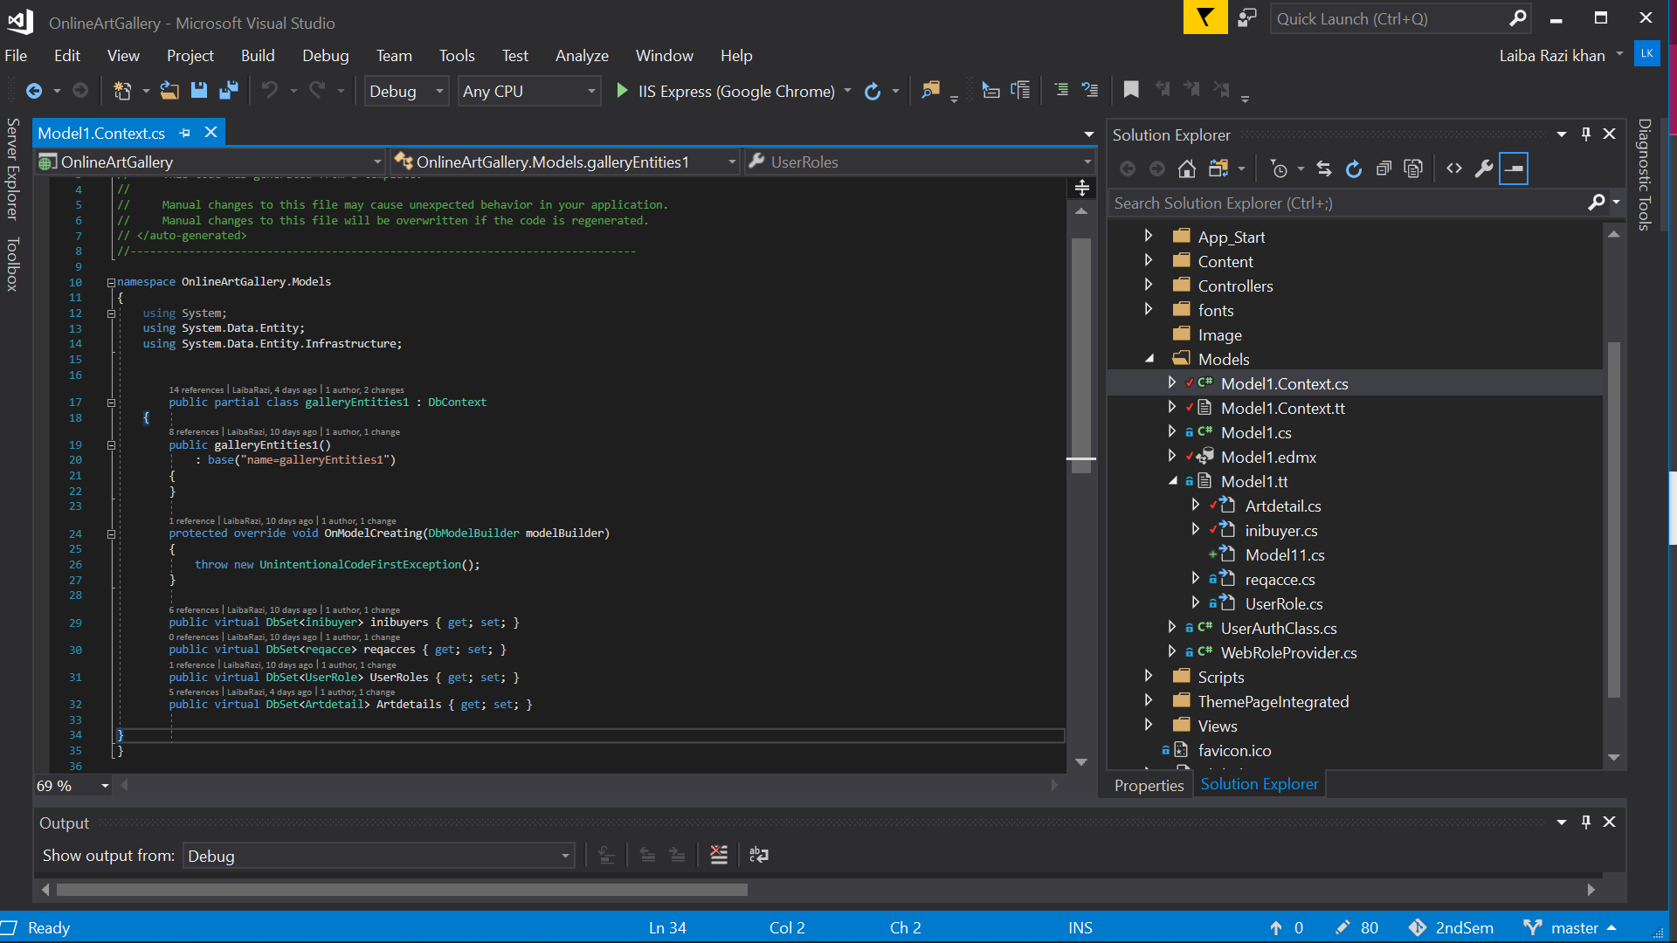

VIEW:

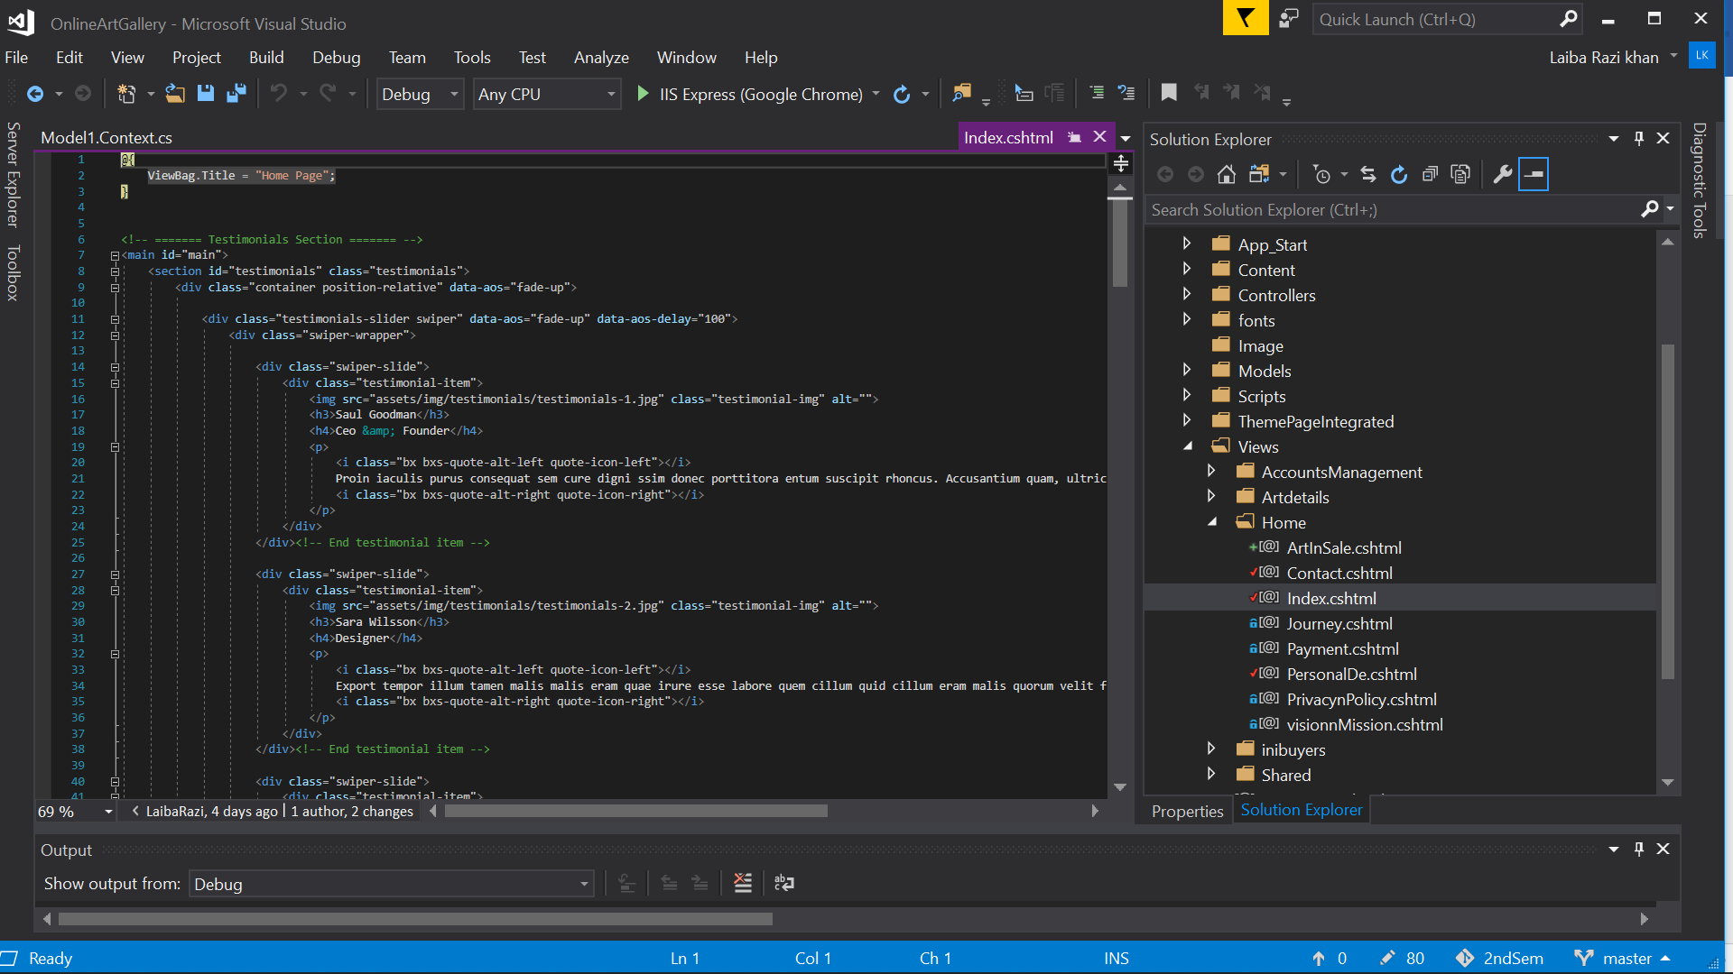

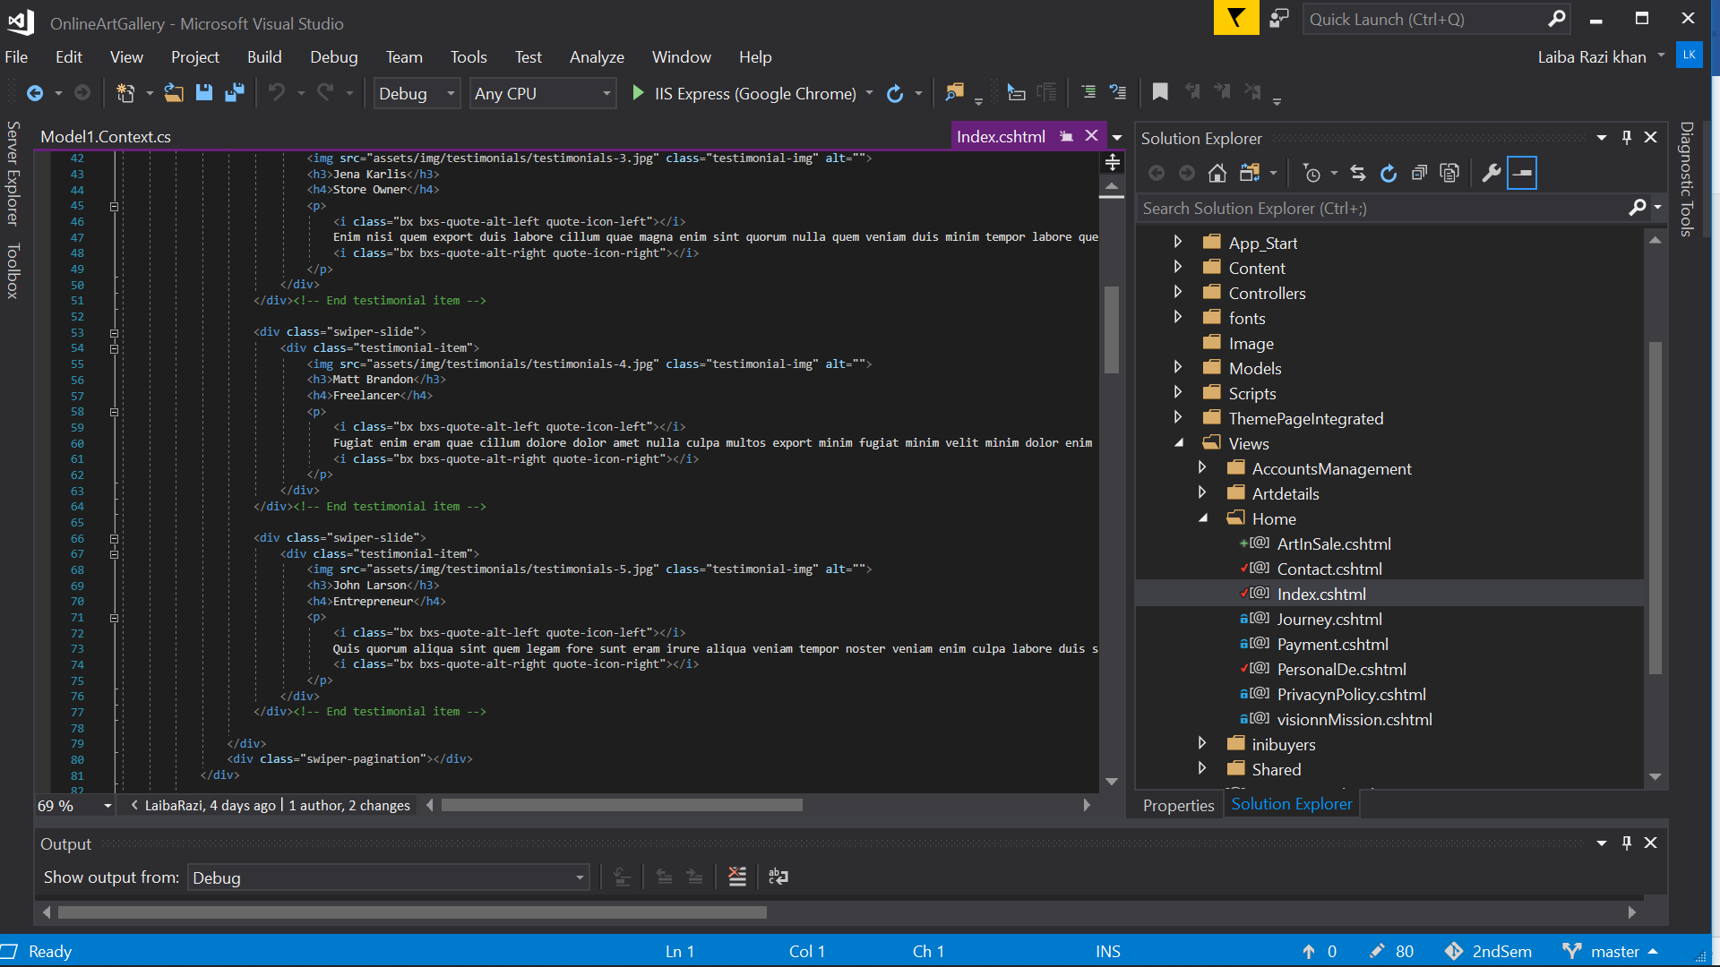

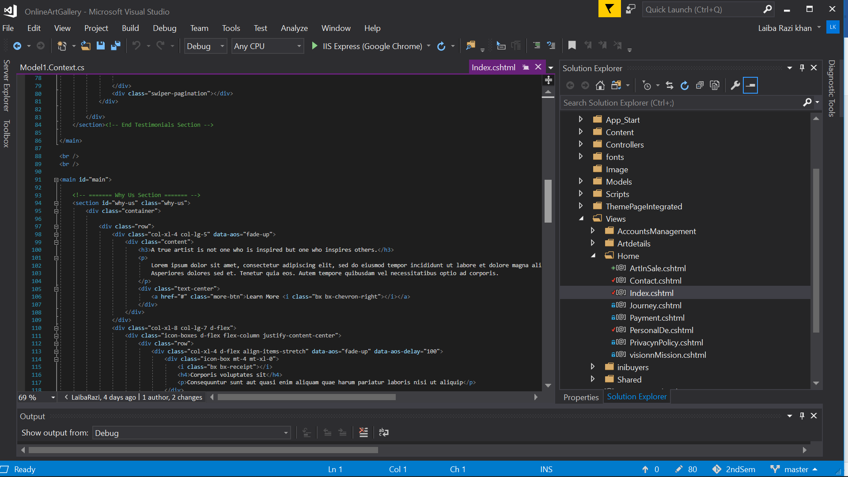

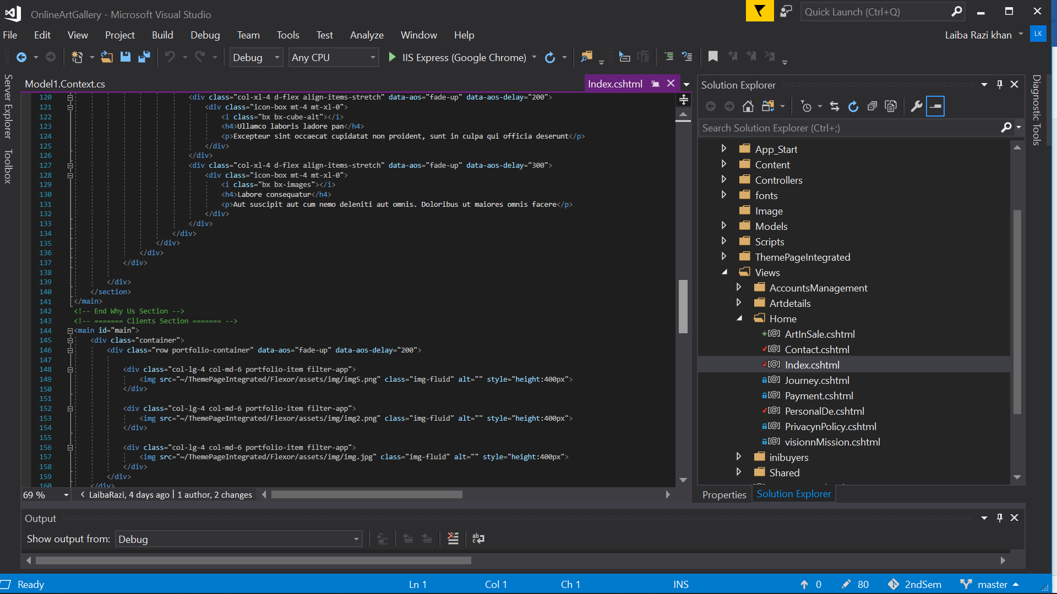

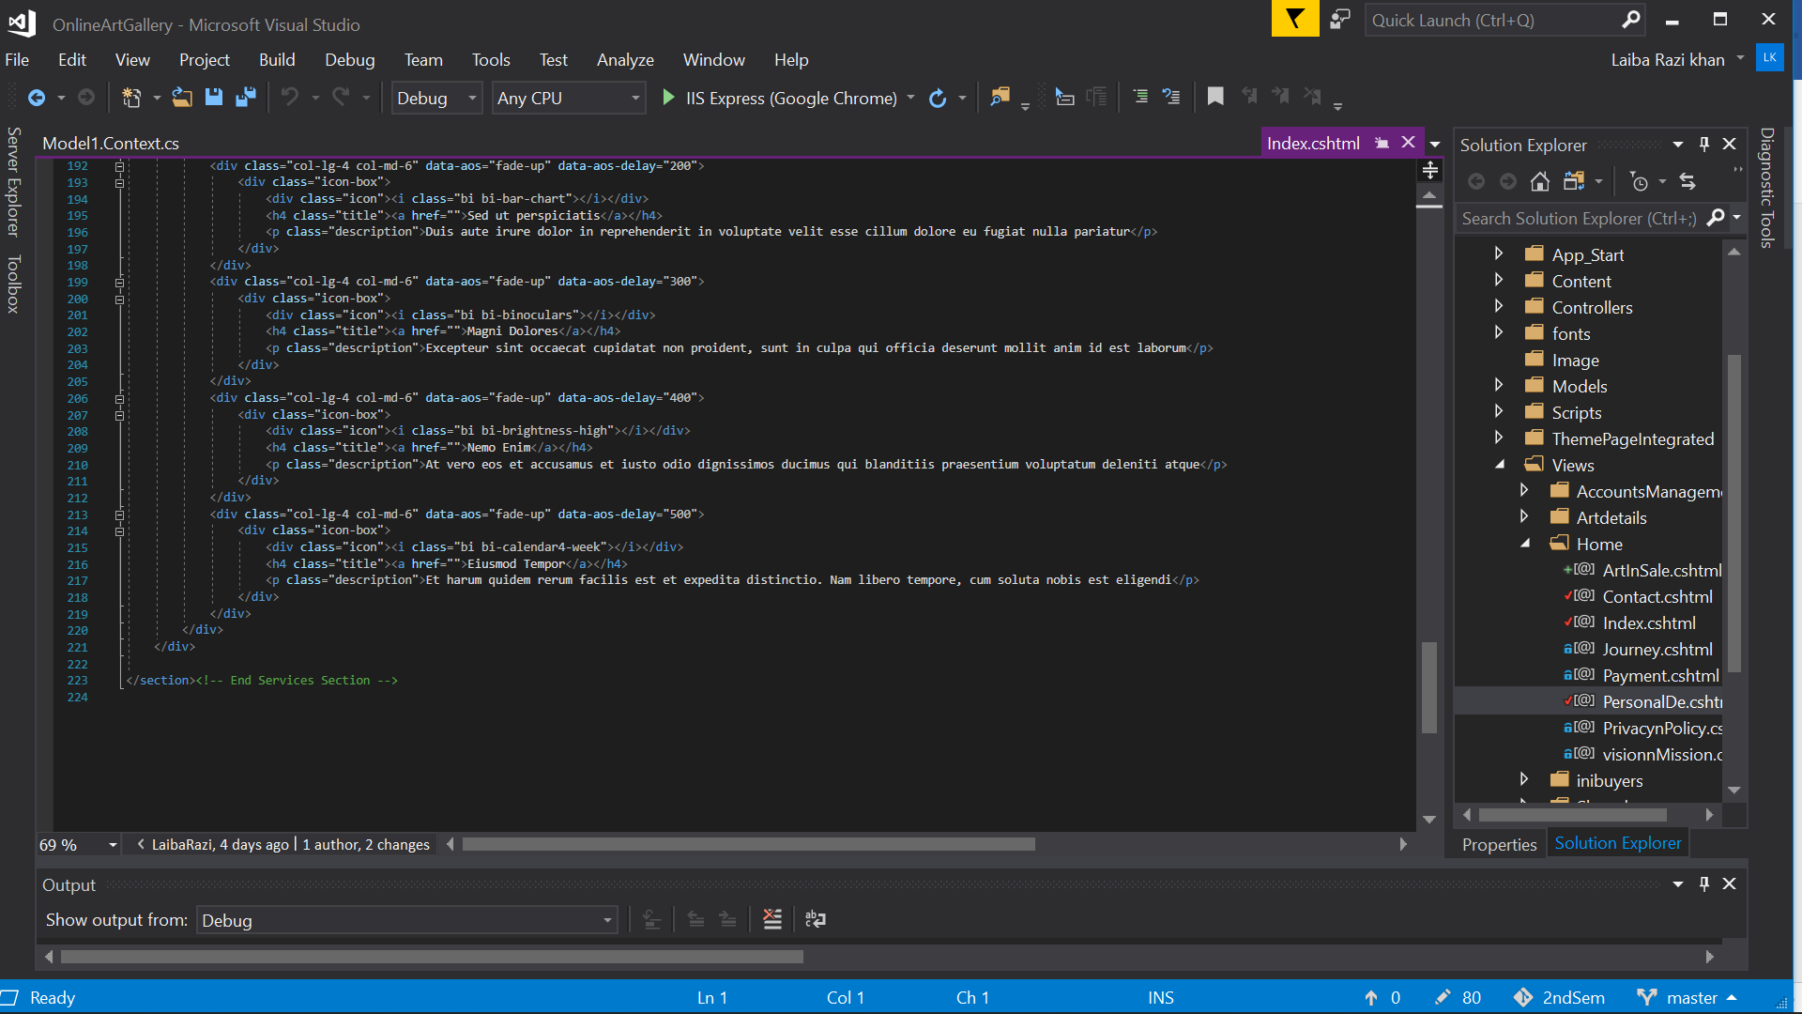

CONTROLLER:

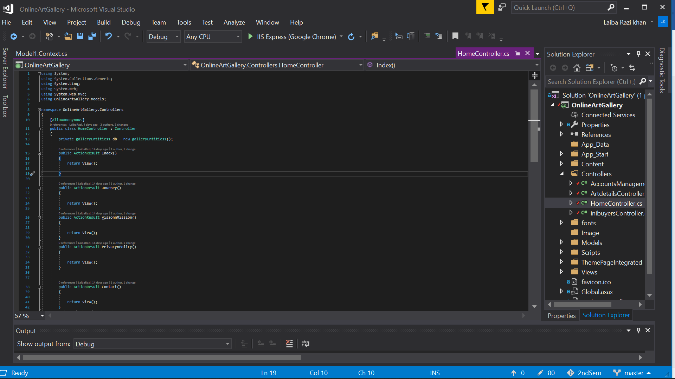

**2.2(b) *JOURNEY***

[GUIDE & CODE]

VIEW:

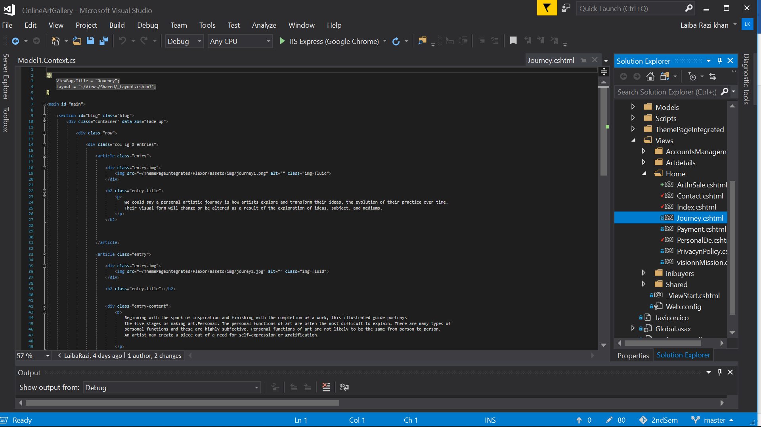

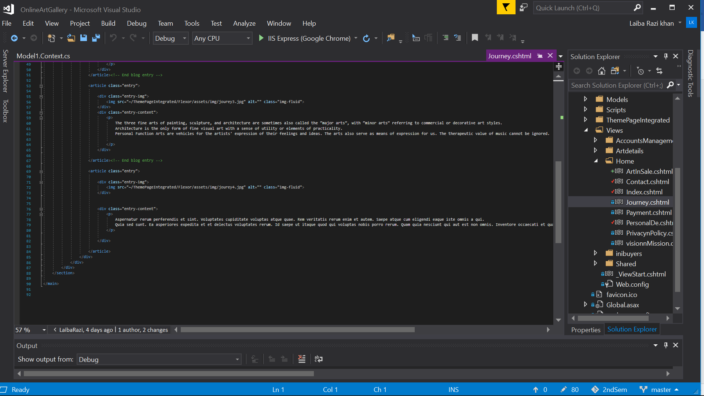

CONTROLLER:



**2.2(c) *VISION & MISSION***

[GUIDE & CODE]

VIEW:

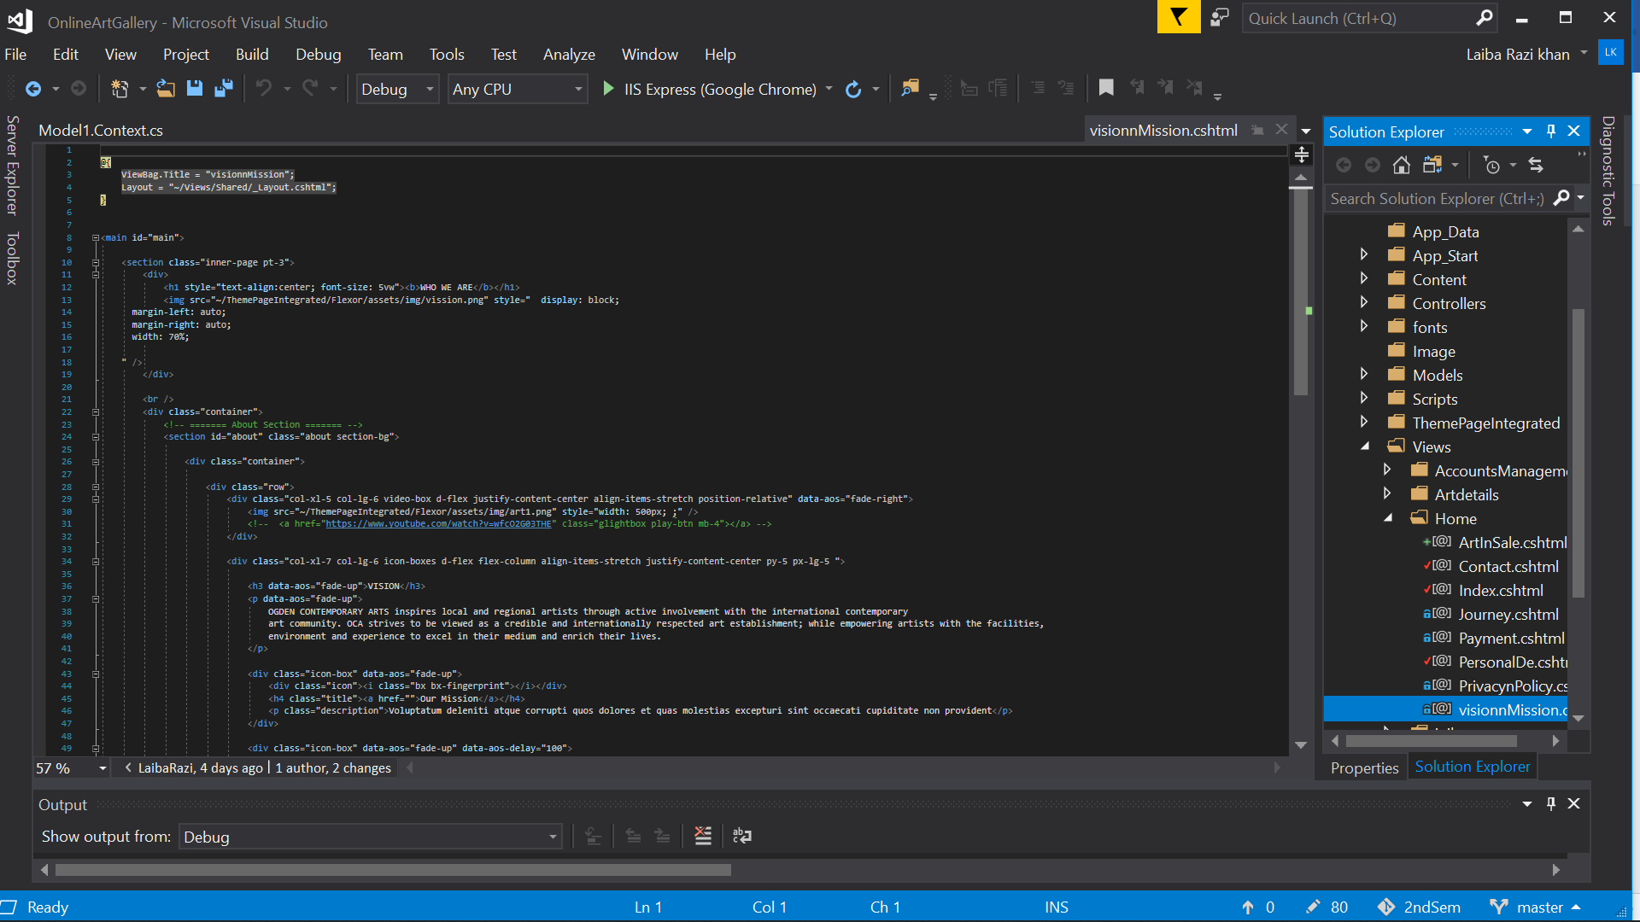

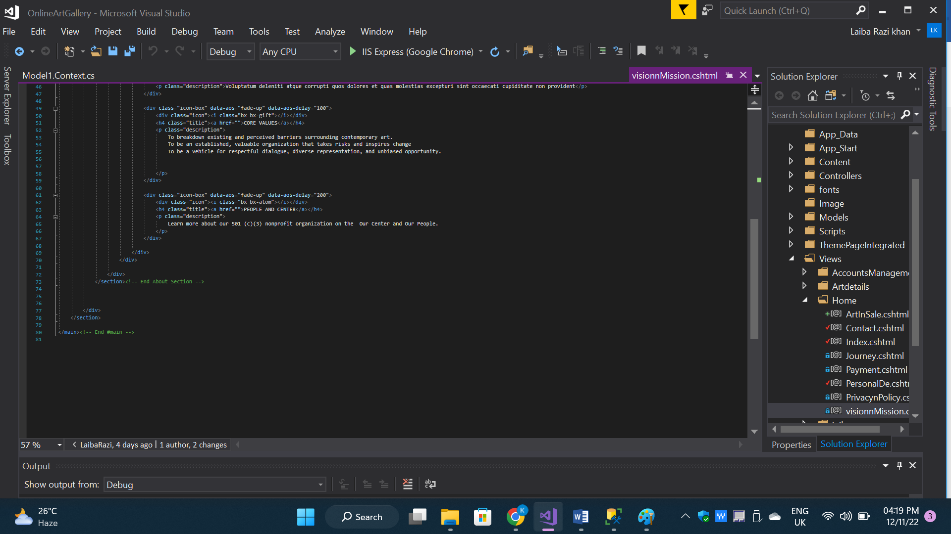

CONTROLLER:



**2.2(d) *PRIVACY POLICY***

[GUIDE & CODE]

VIEW:

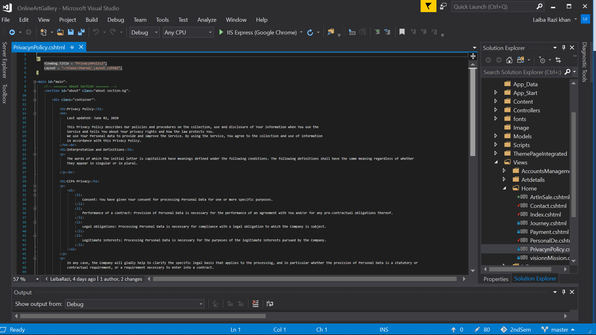

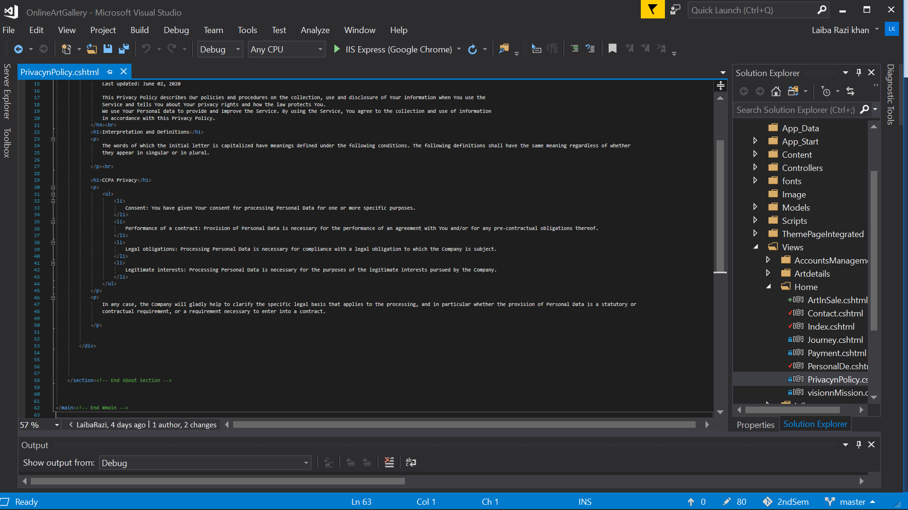

CONTROLLER:



**2.2(e) *CONTACT***

[GUIDE & CODE]

VIEW: 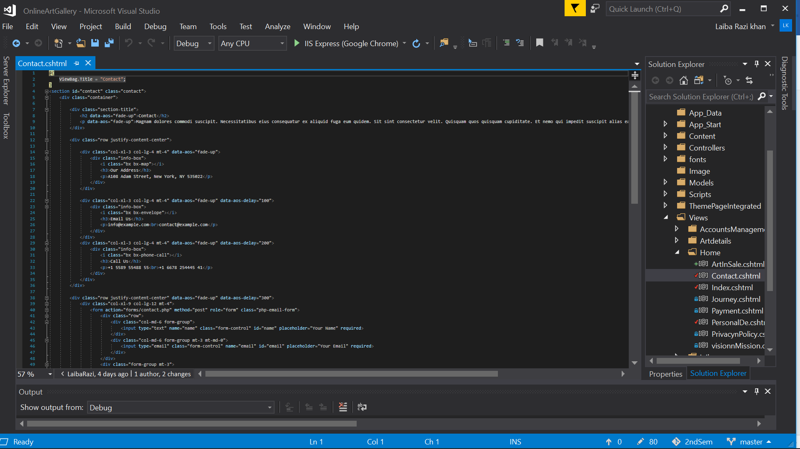

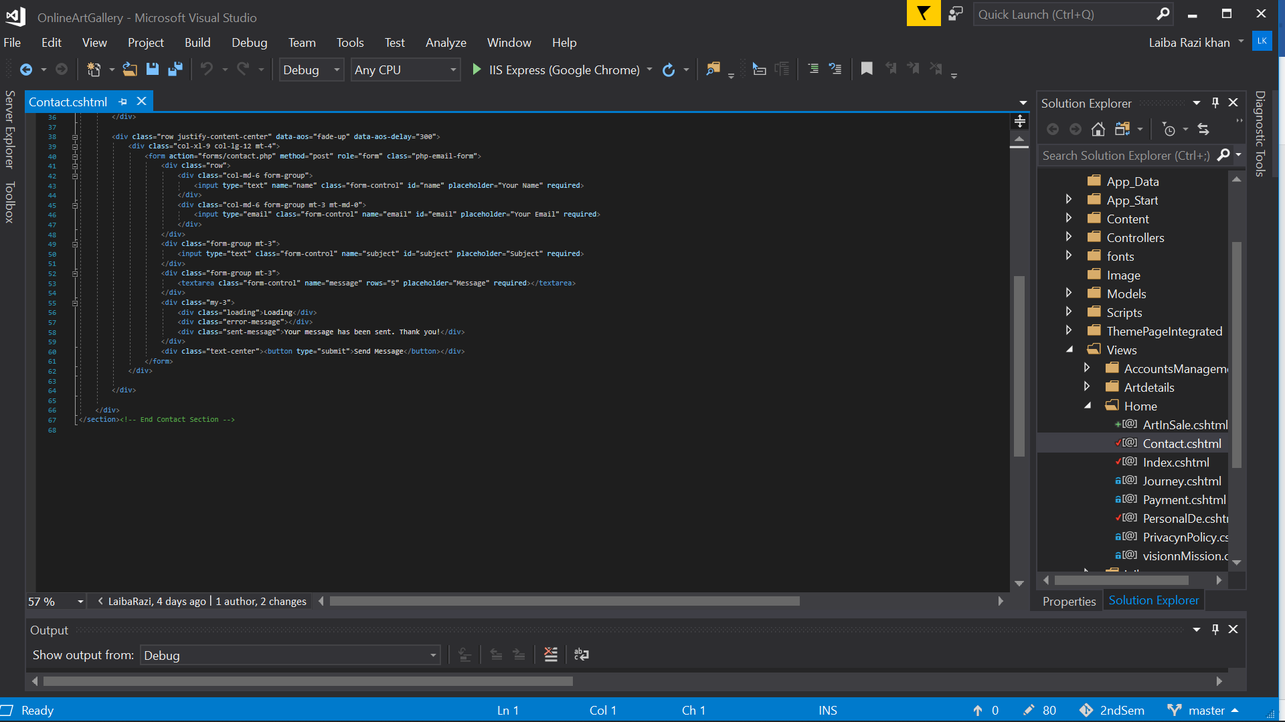

CONTROLLER:



**2.3 ACCOUNT MANAGEMENT(*LOGIN AND SIGNUP*)**

Account-Management deals with login and signup with respect to roles.

[GUIDE & CODE]

MODEL:

VIEW:

Sign up will help you to enter all the details in SQL table “inibuyer”:

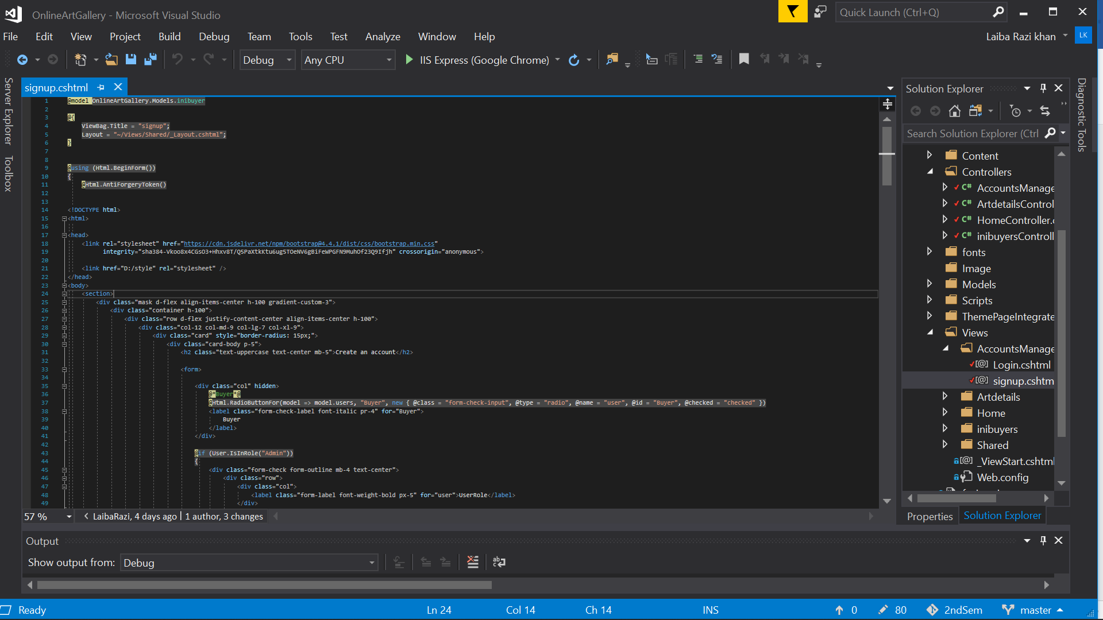

In sign-up when Admin Create Account personally,he could create another admin’s account to pass authorities meanwhile buyer don’t have such facilities

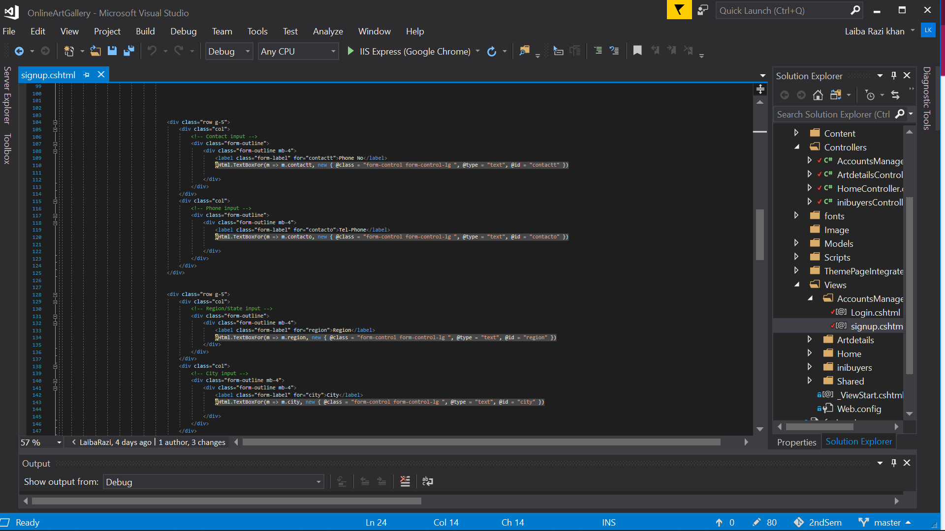

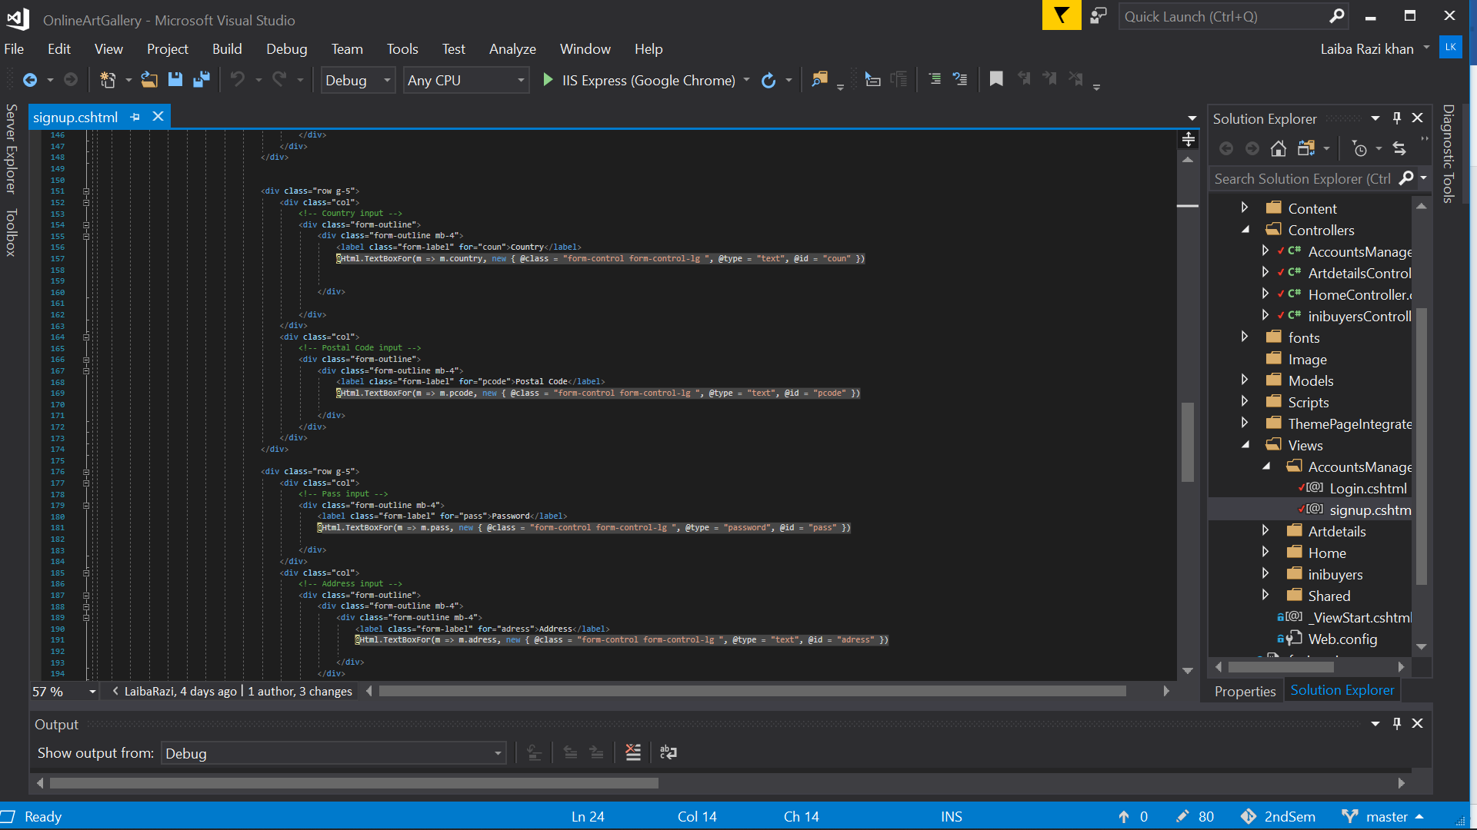

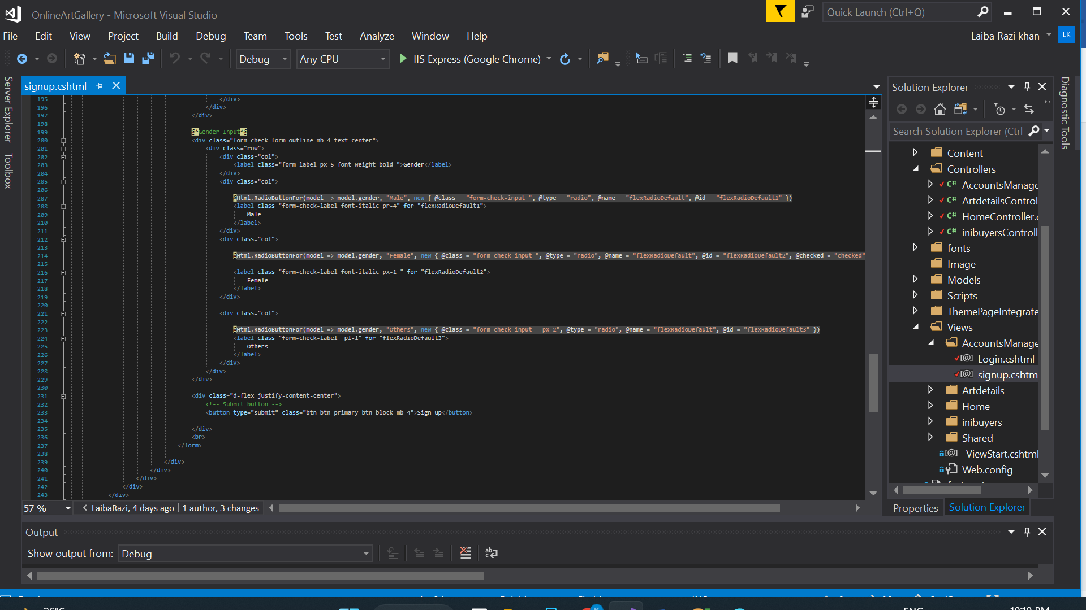

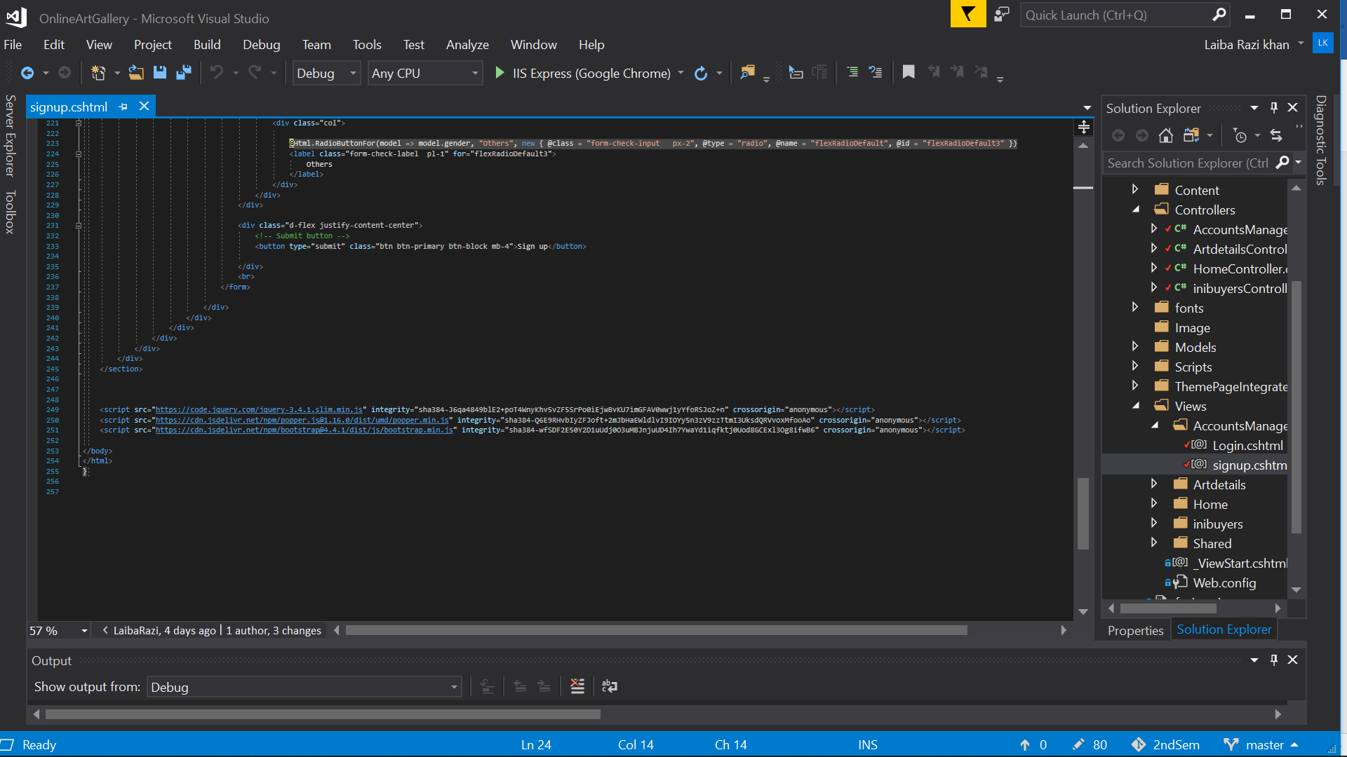

You will be able to login with the details which you have entered in sign up:

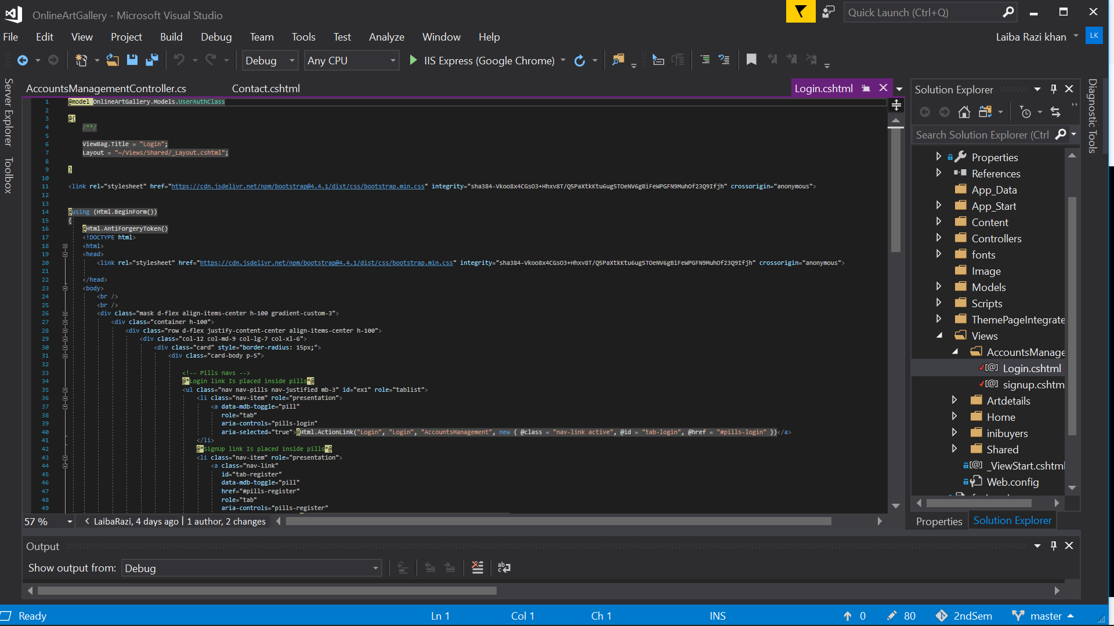

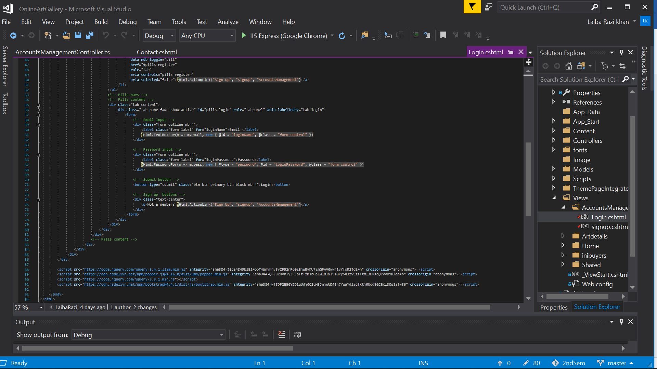

CONTROLLER:

Signup is action result will insert all the data in sign up form in SQL table “inibuyer”

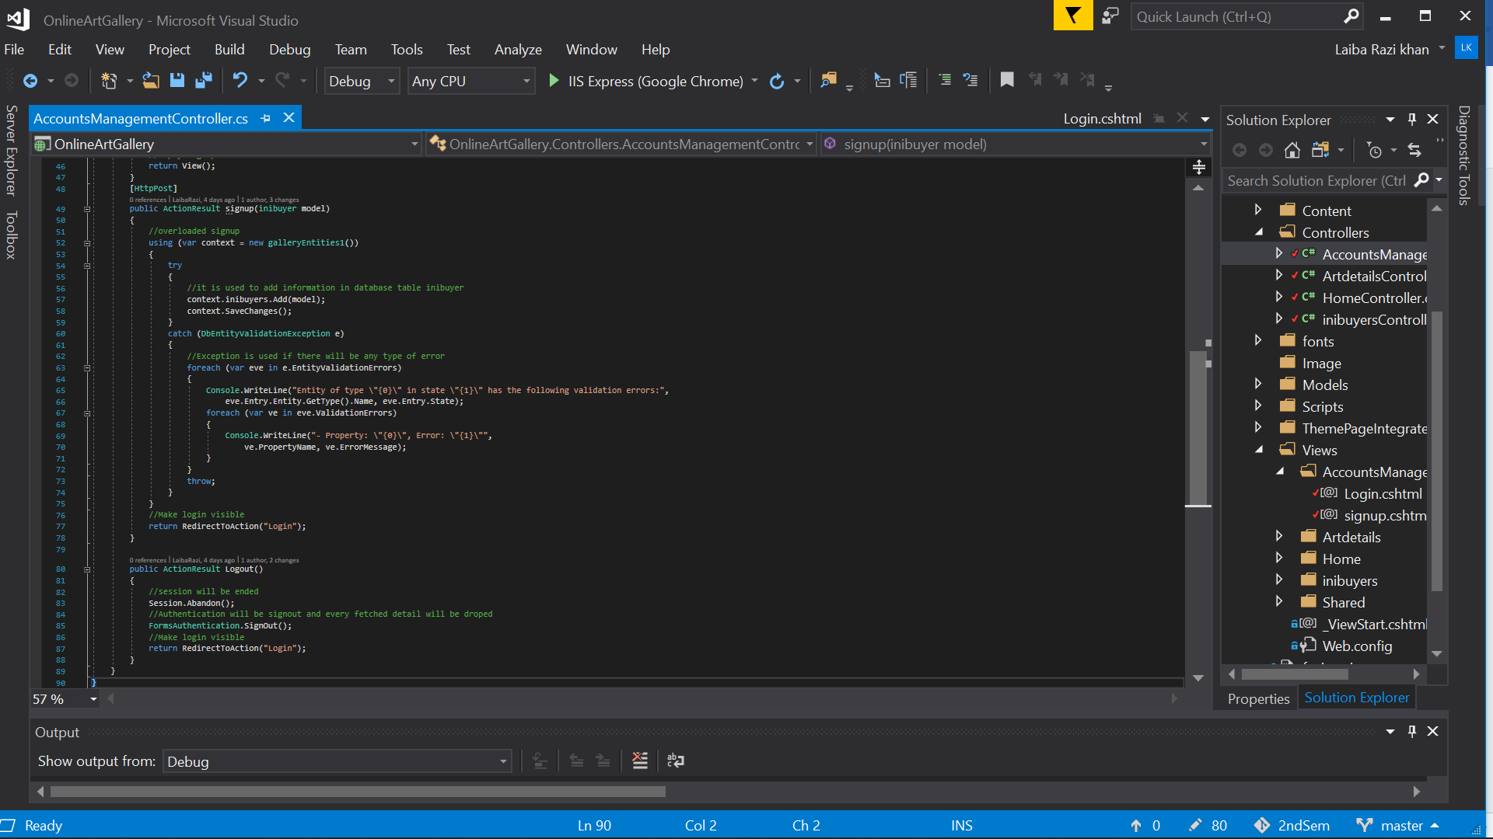

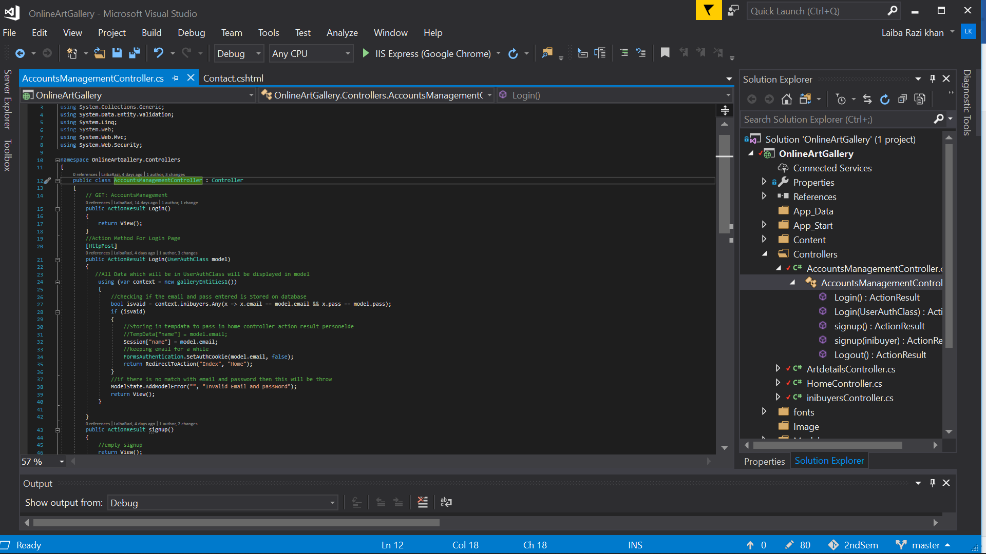

Login helps to get data of userauth class and check that information whether it matches from SQL data



Logout is userd to abandon session and signout from authenticated user

**2.4 INIBUYER = USER INFORMATION(*INDEX, DETAILS & IMAGE UPLOADING*)**

MODEL:

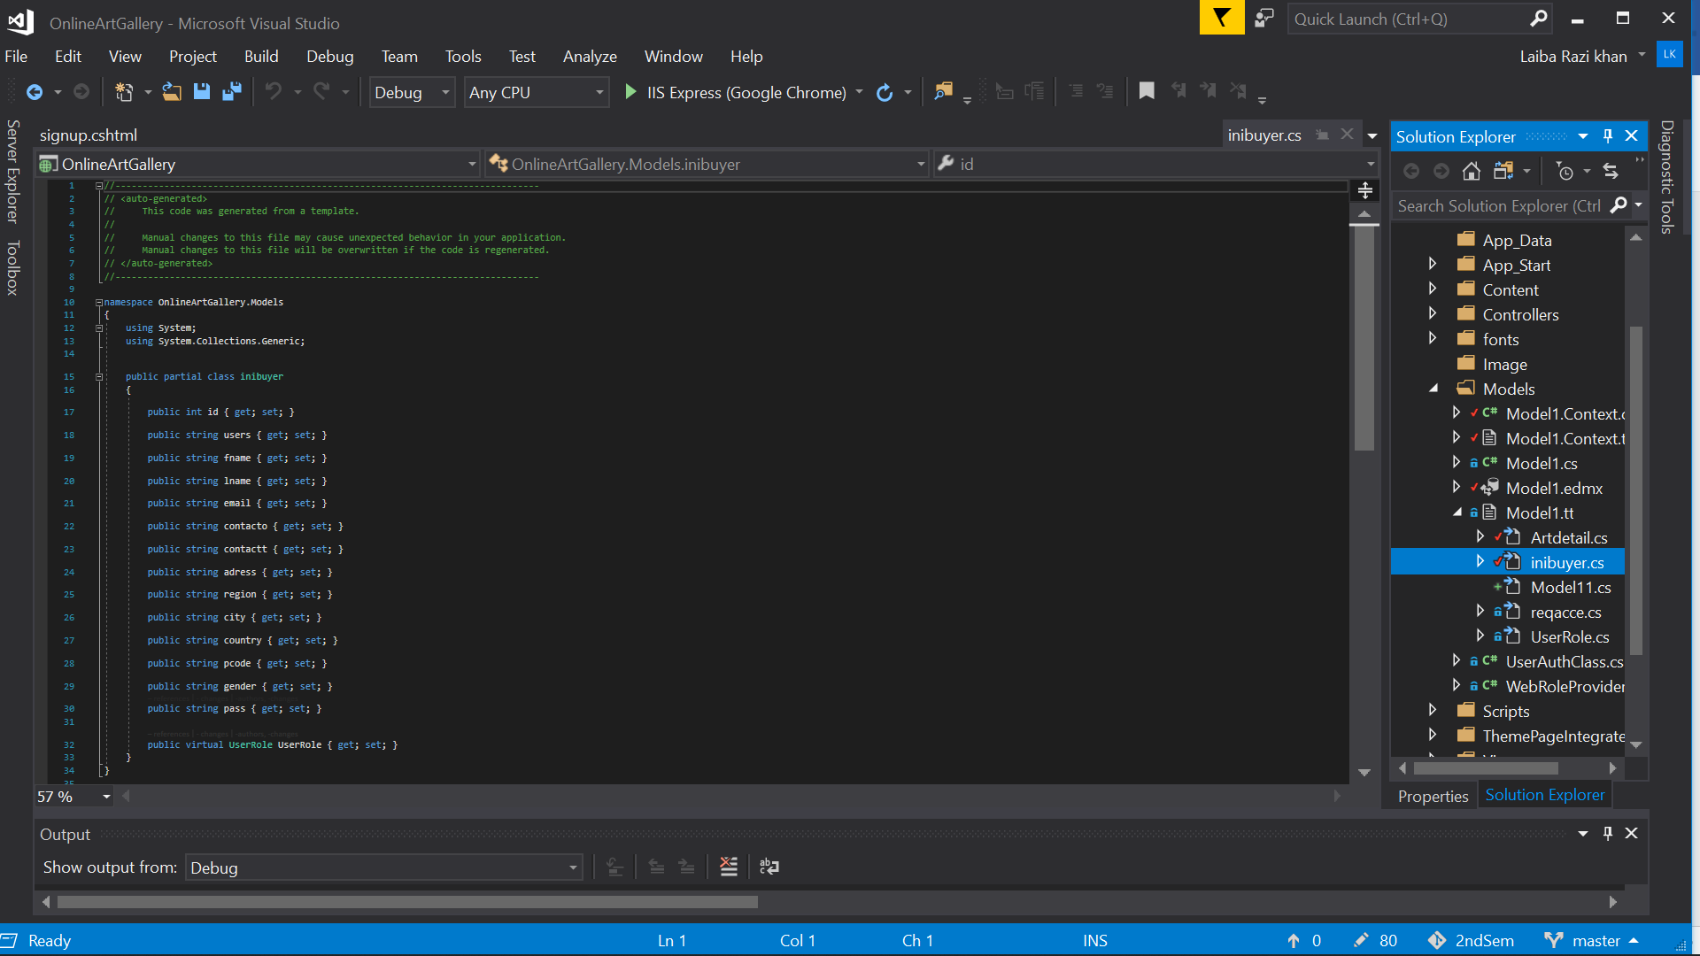

iit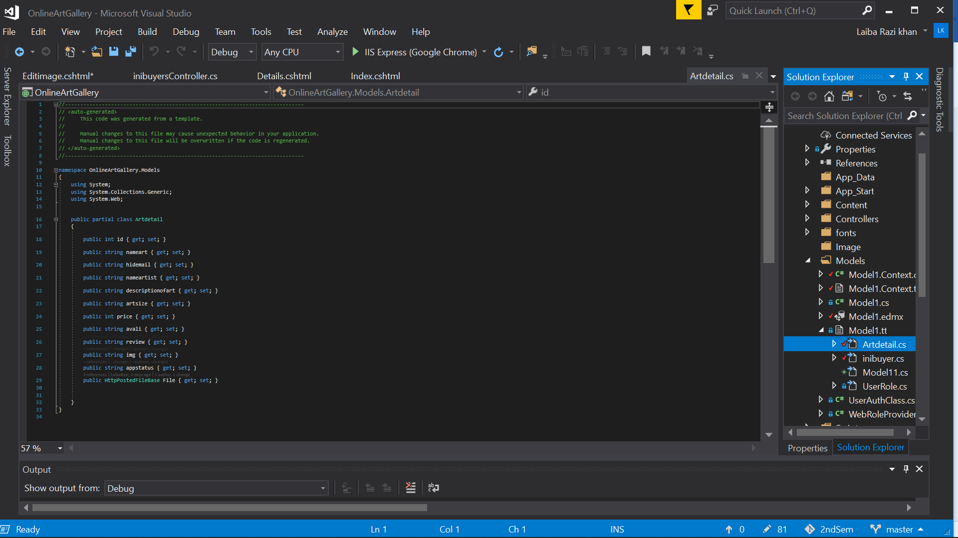

ArtDetail.cs will fetch all the values and transfer it into SQL table & HttpPostedFileBase will post it in Image Folder

VIEW:

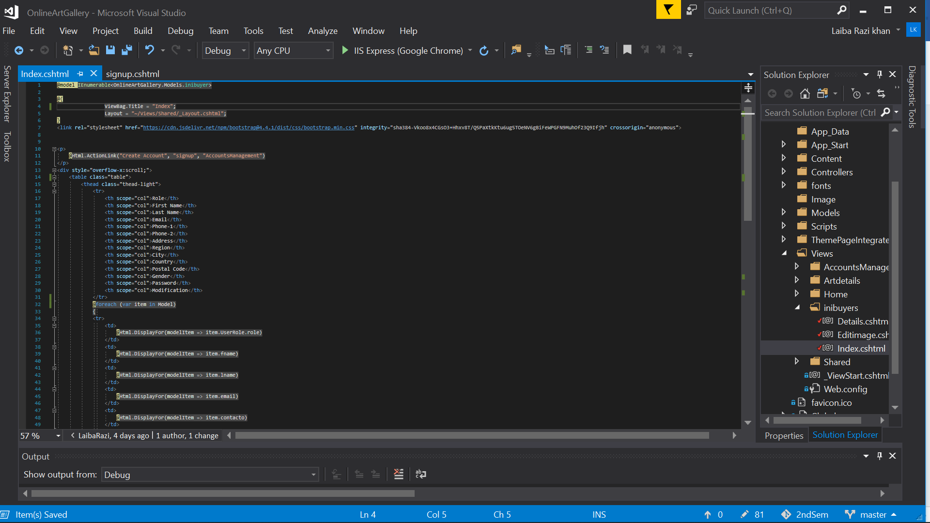

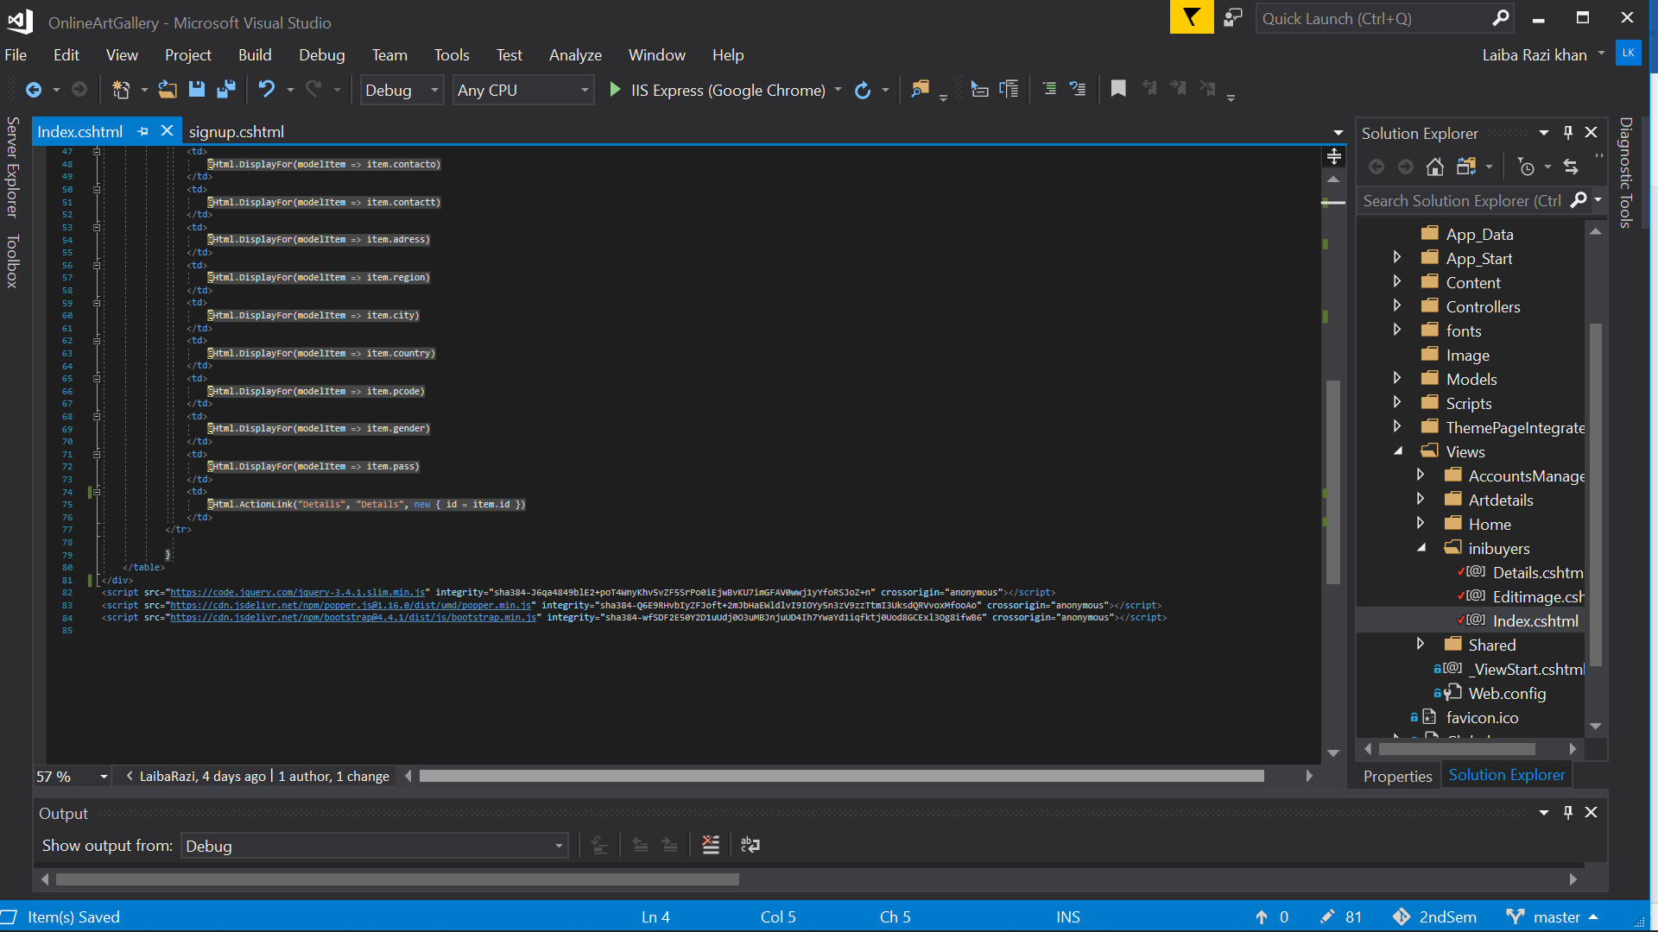

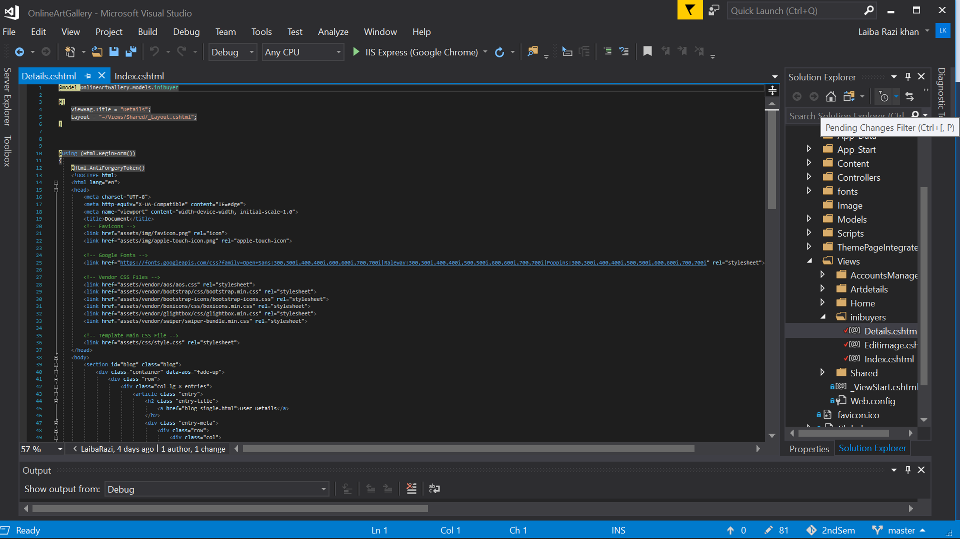

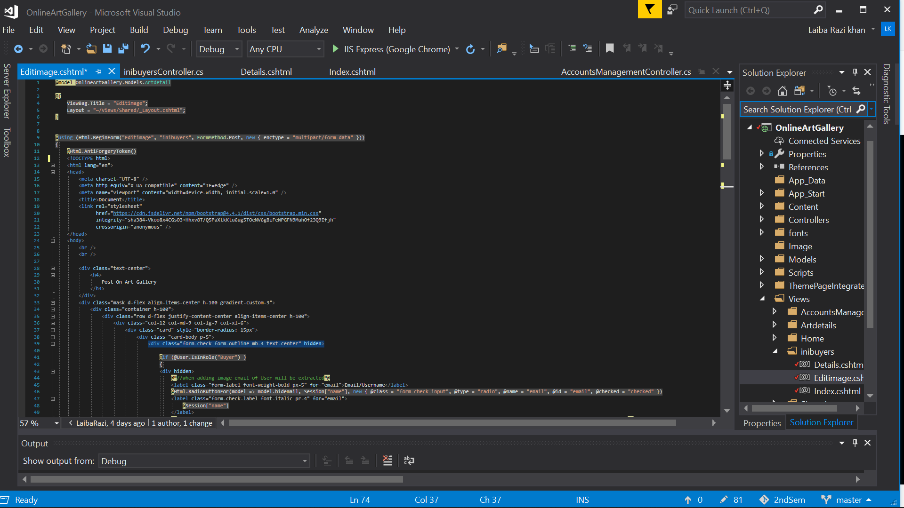

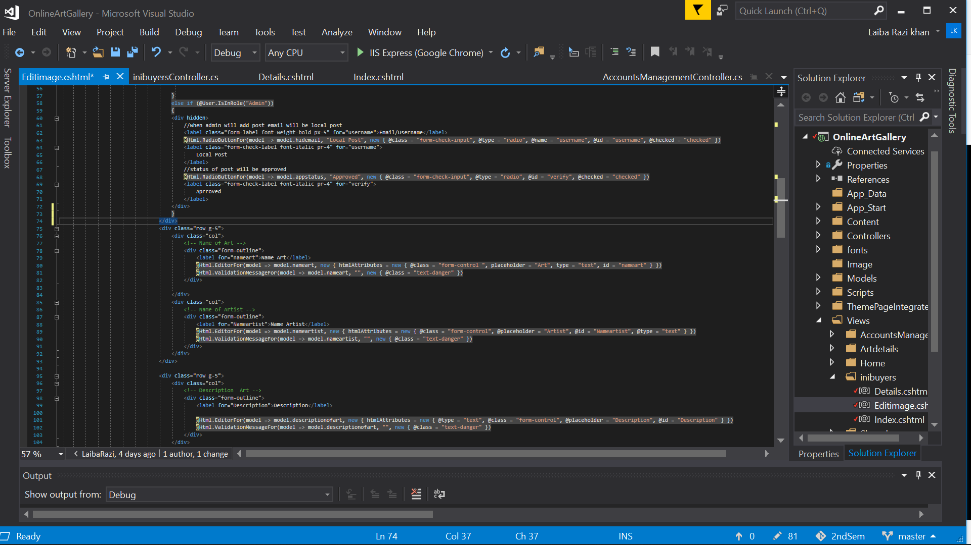

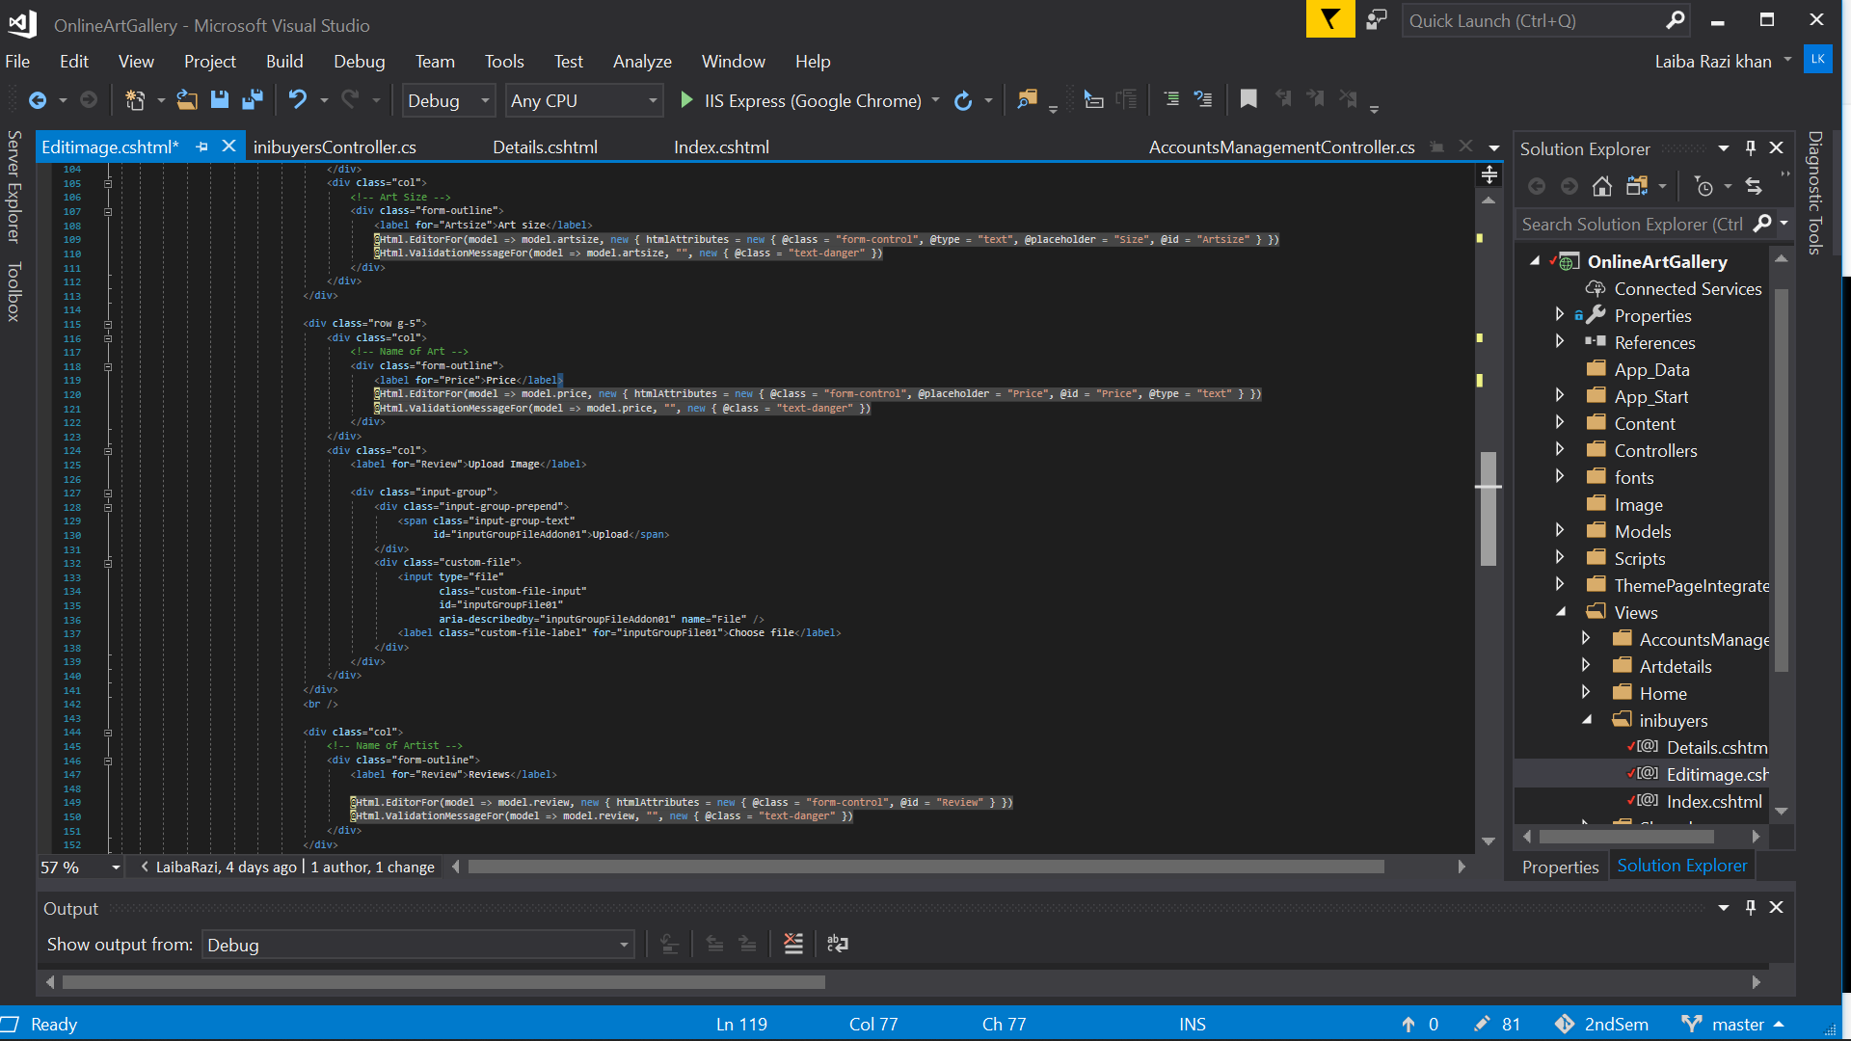

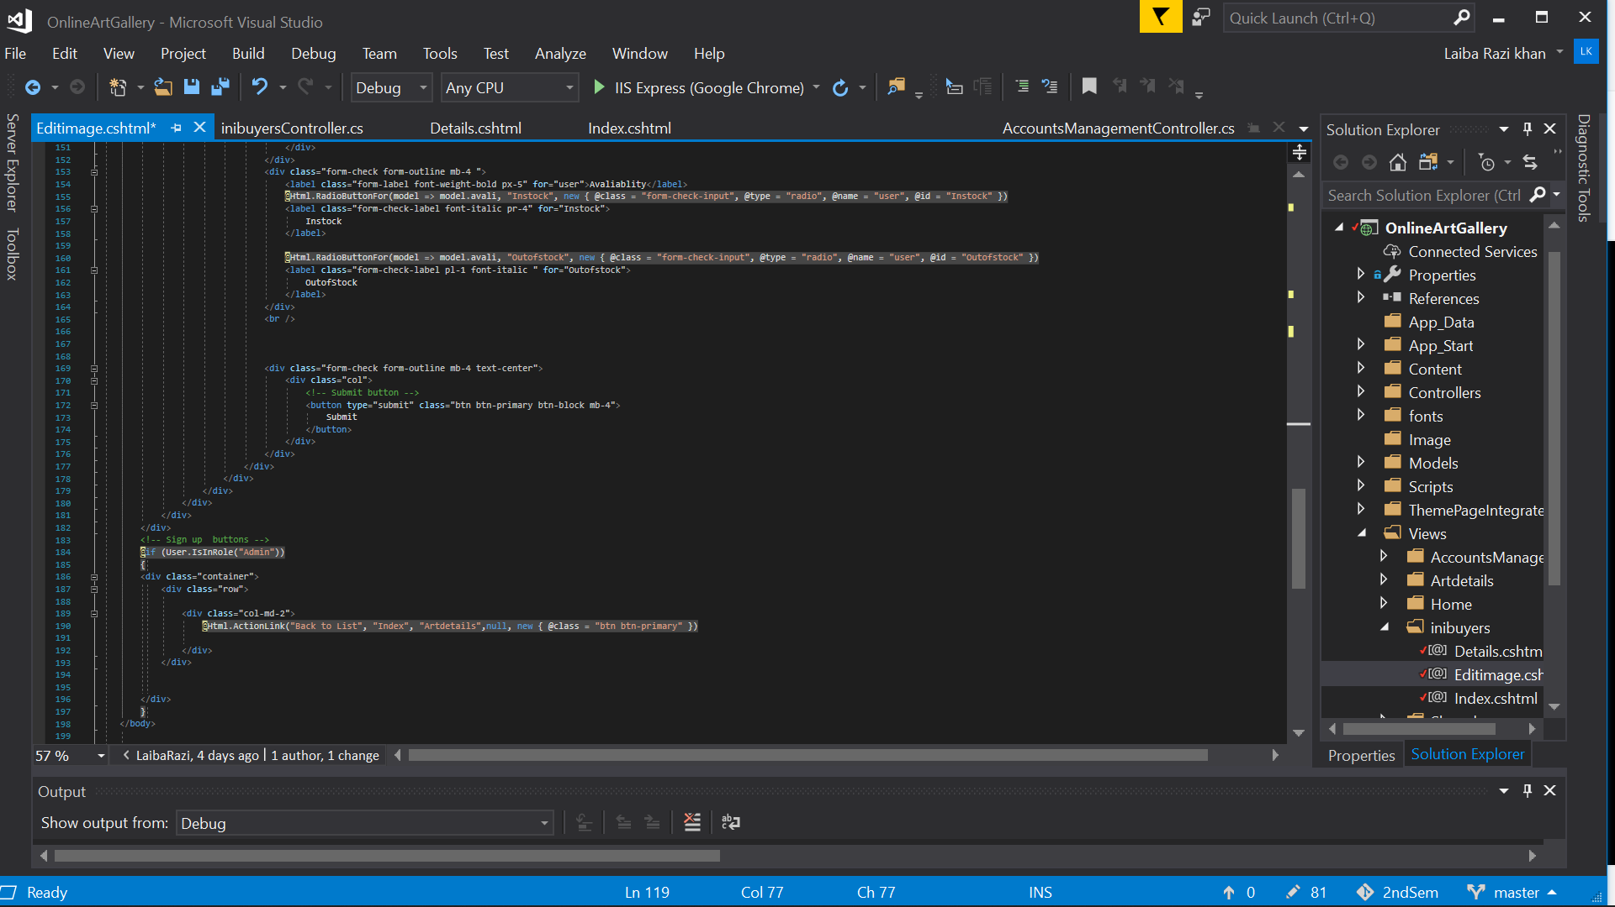

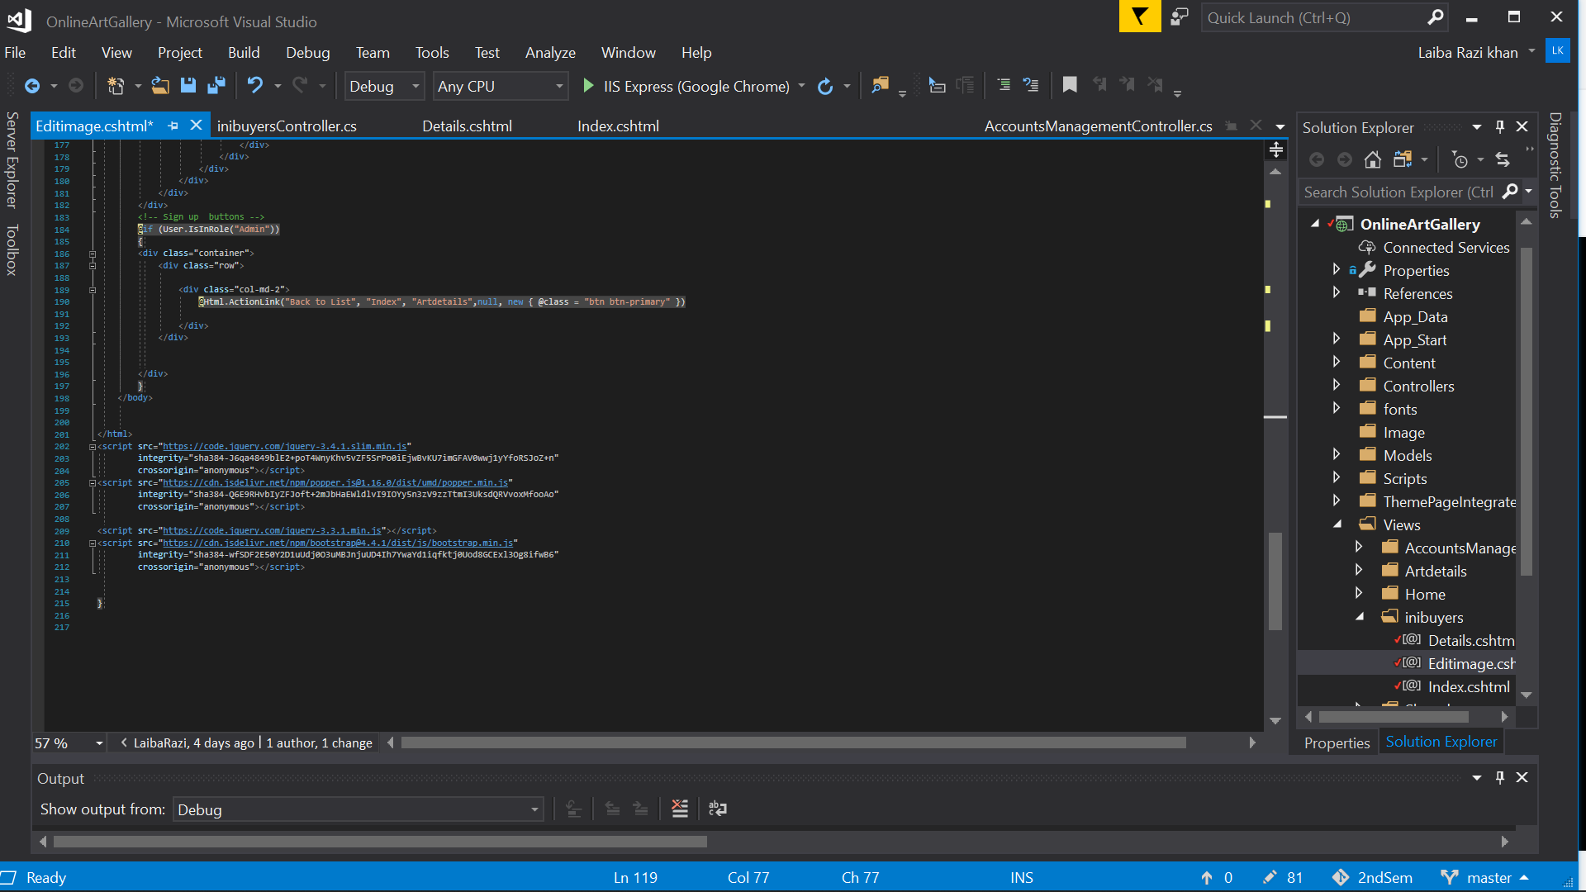

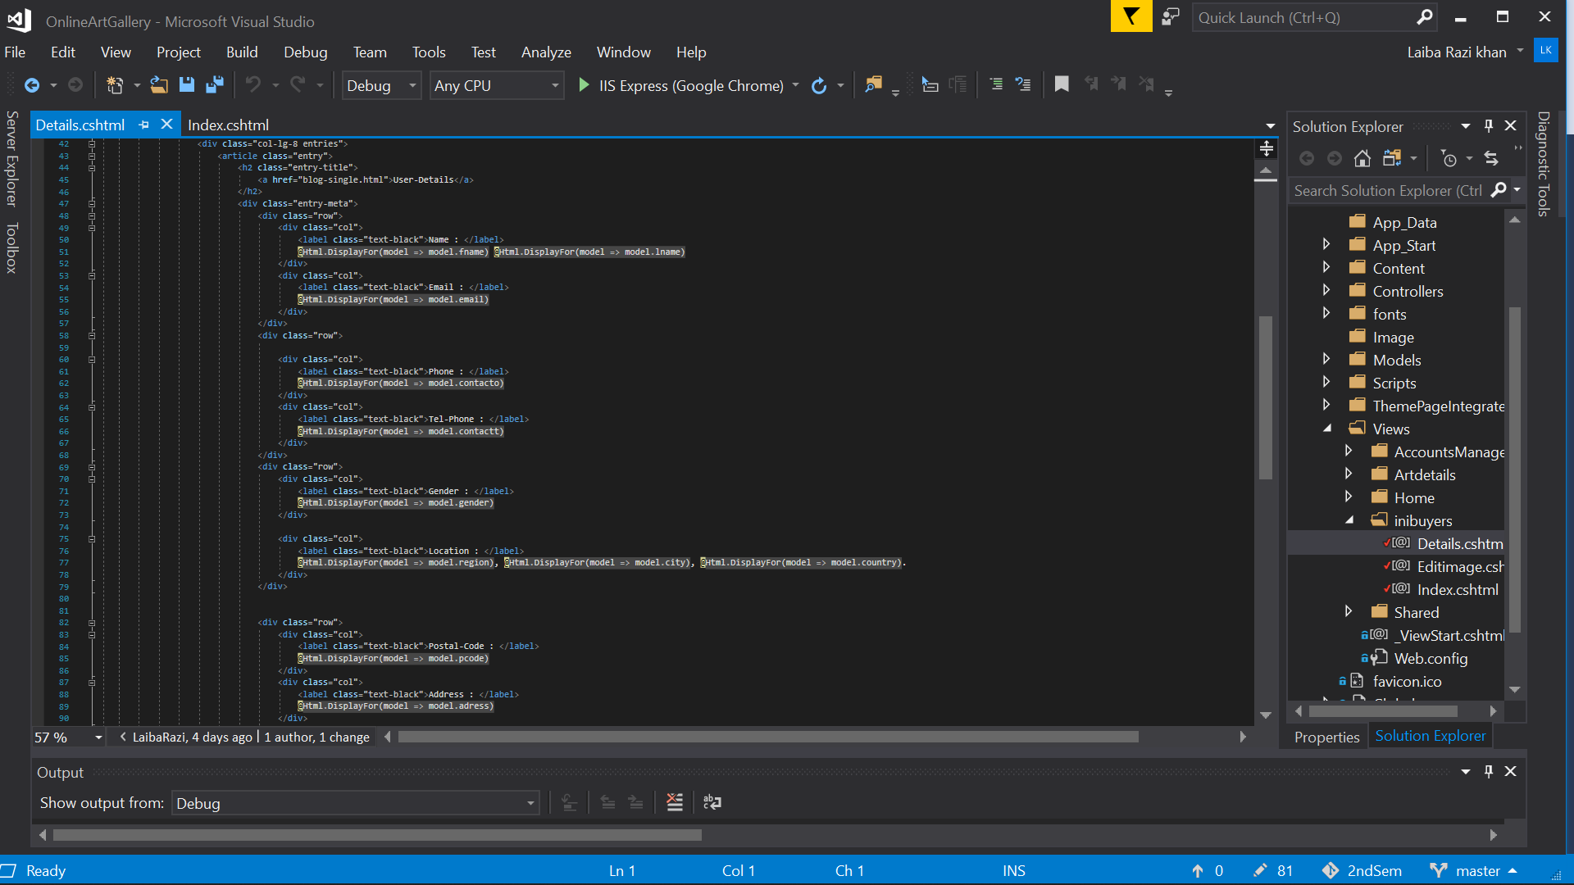

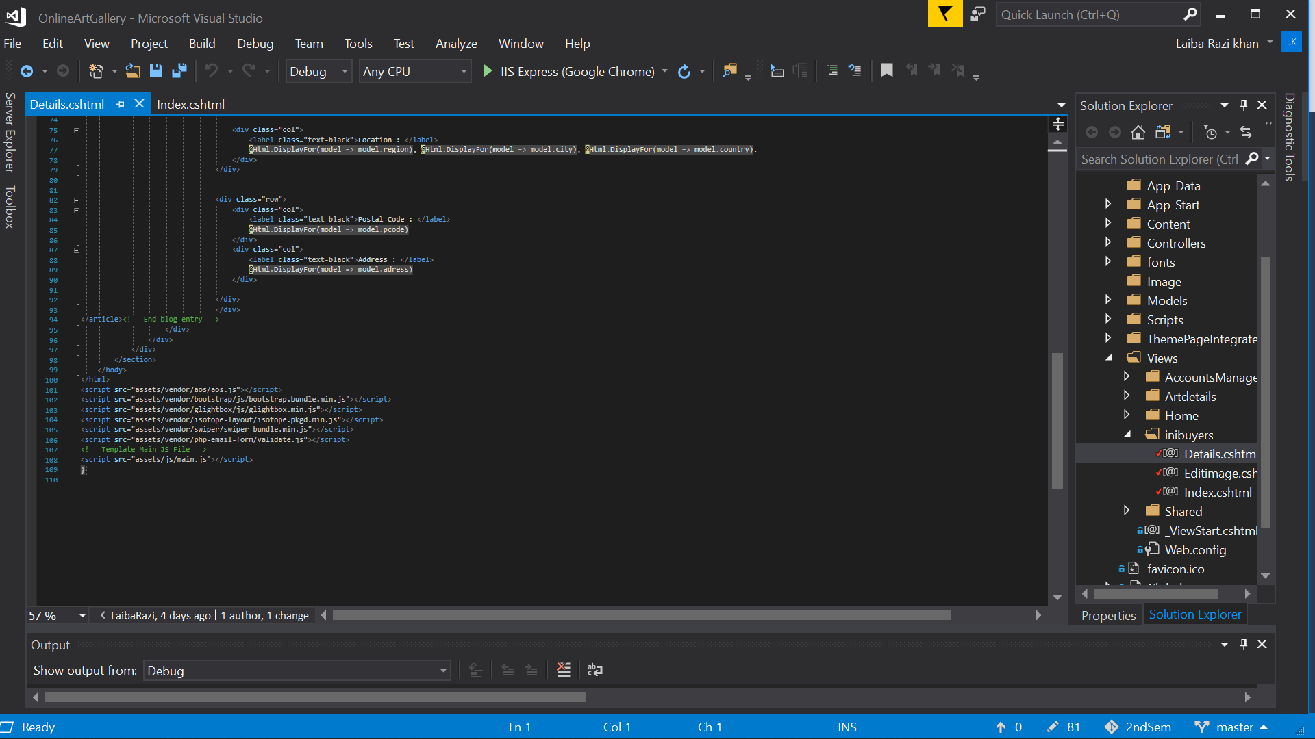

CONTROLLER:

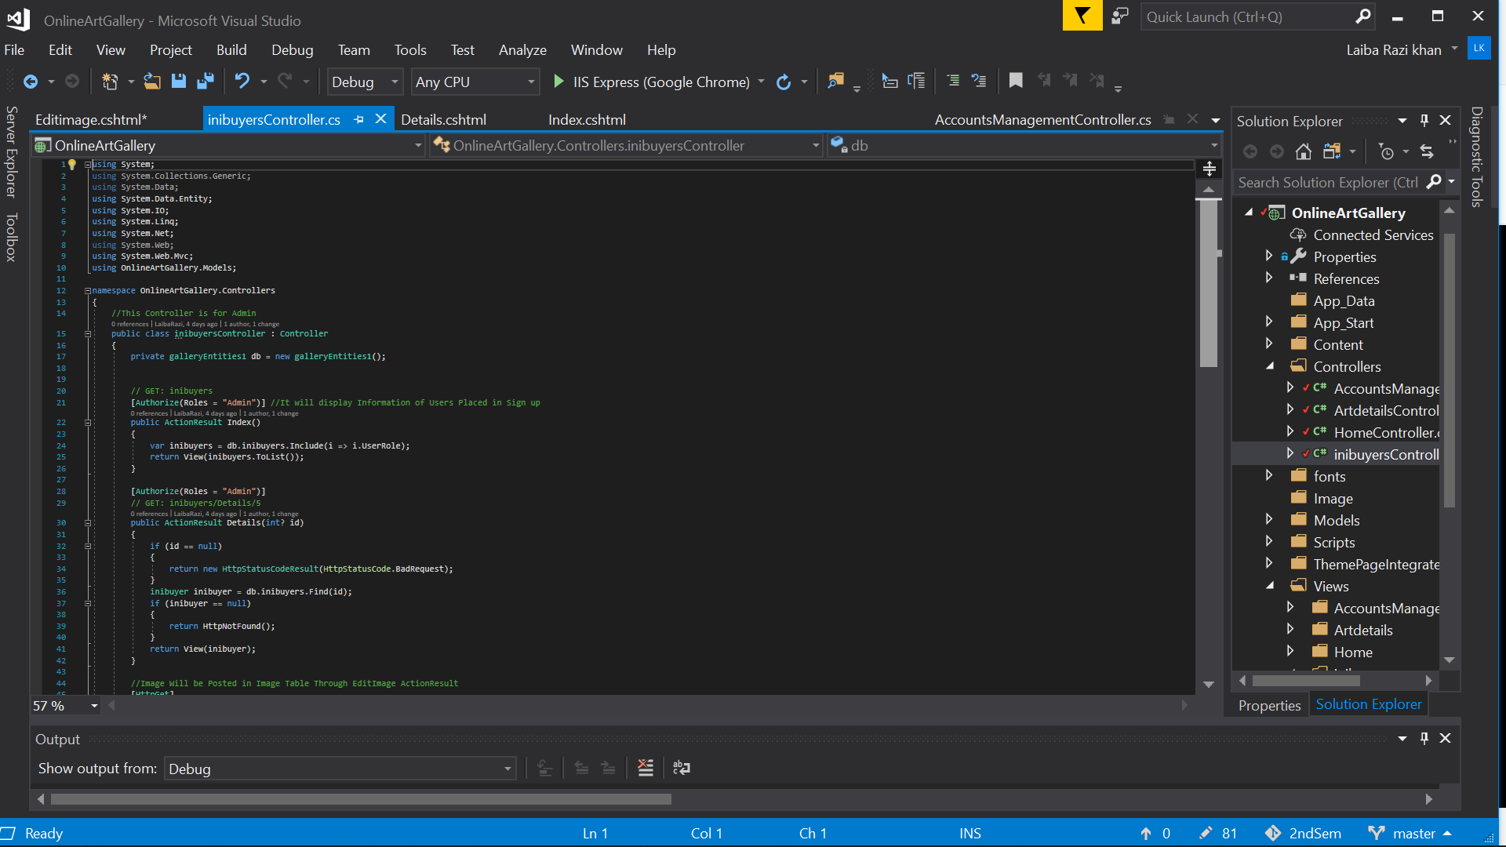

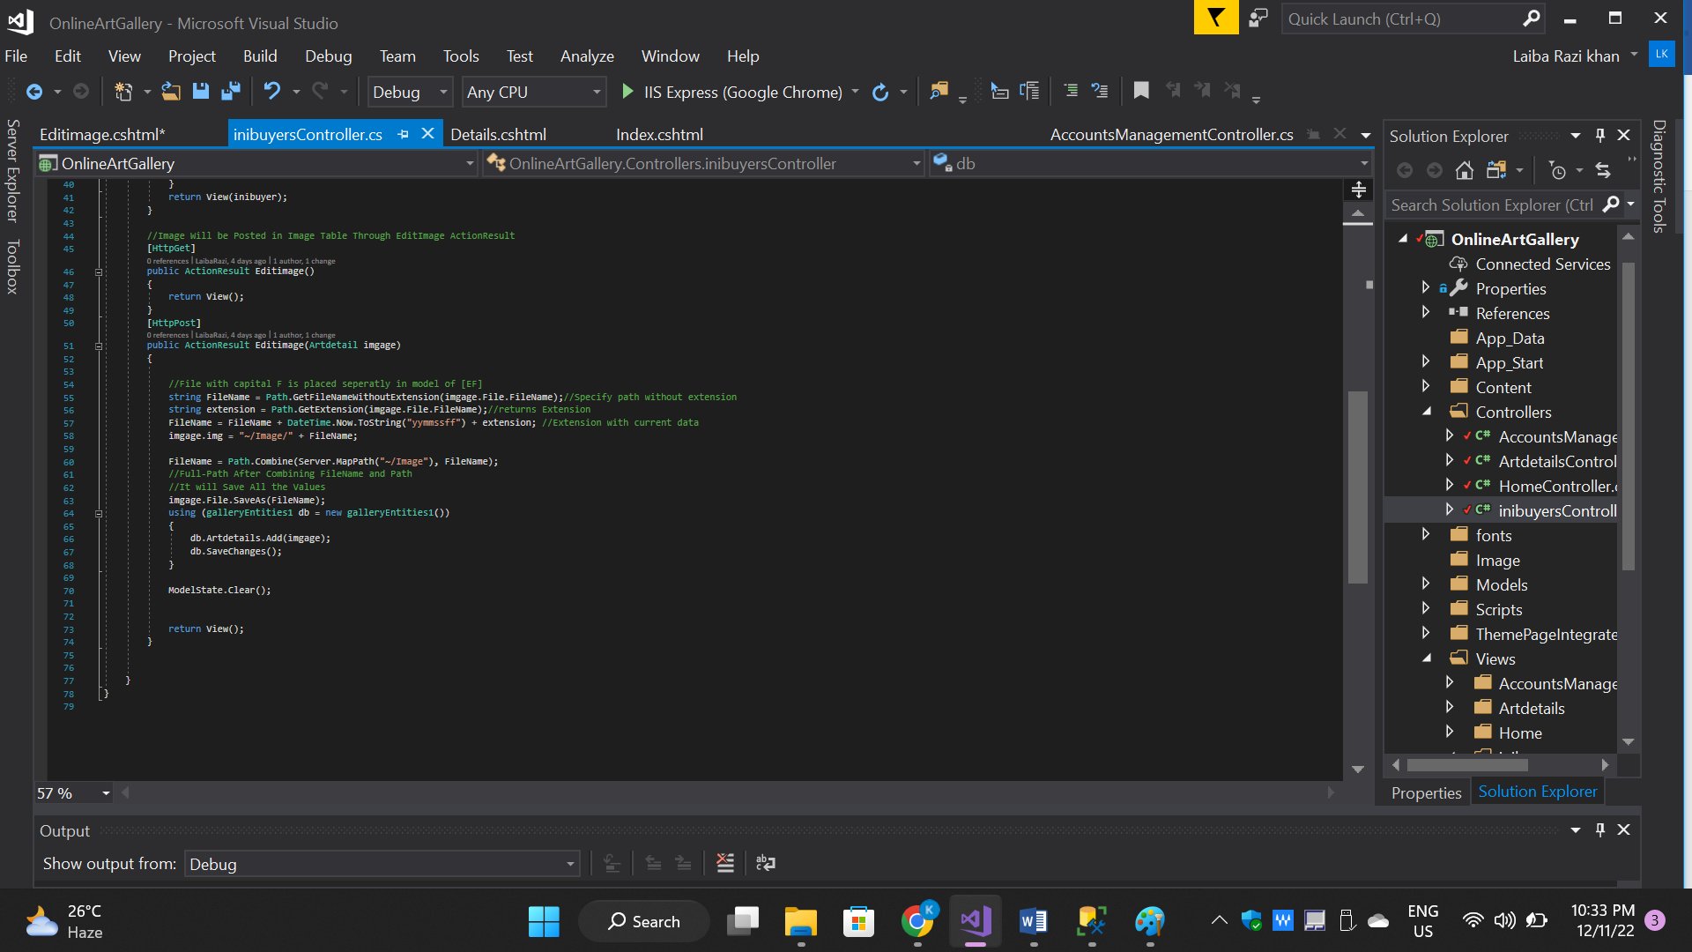

**2.4 ART-DEATAILS (*INDEX,EDIT & DETAIL)***

Art Detail is responsible to show all the details of painting to user in “Art In Sale” ,

Only Admin could go in Art-Detail to view all the records and could approve them or disapprove them

If the post is disapproved than it couldn’t be shown on “Art In Sale”.

MODEL:

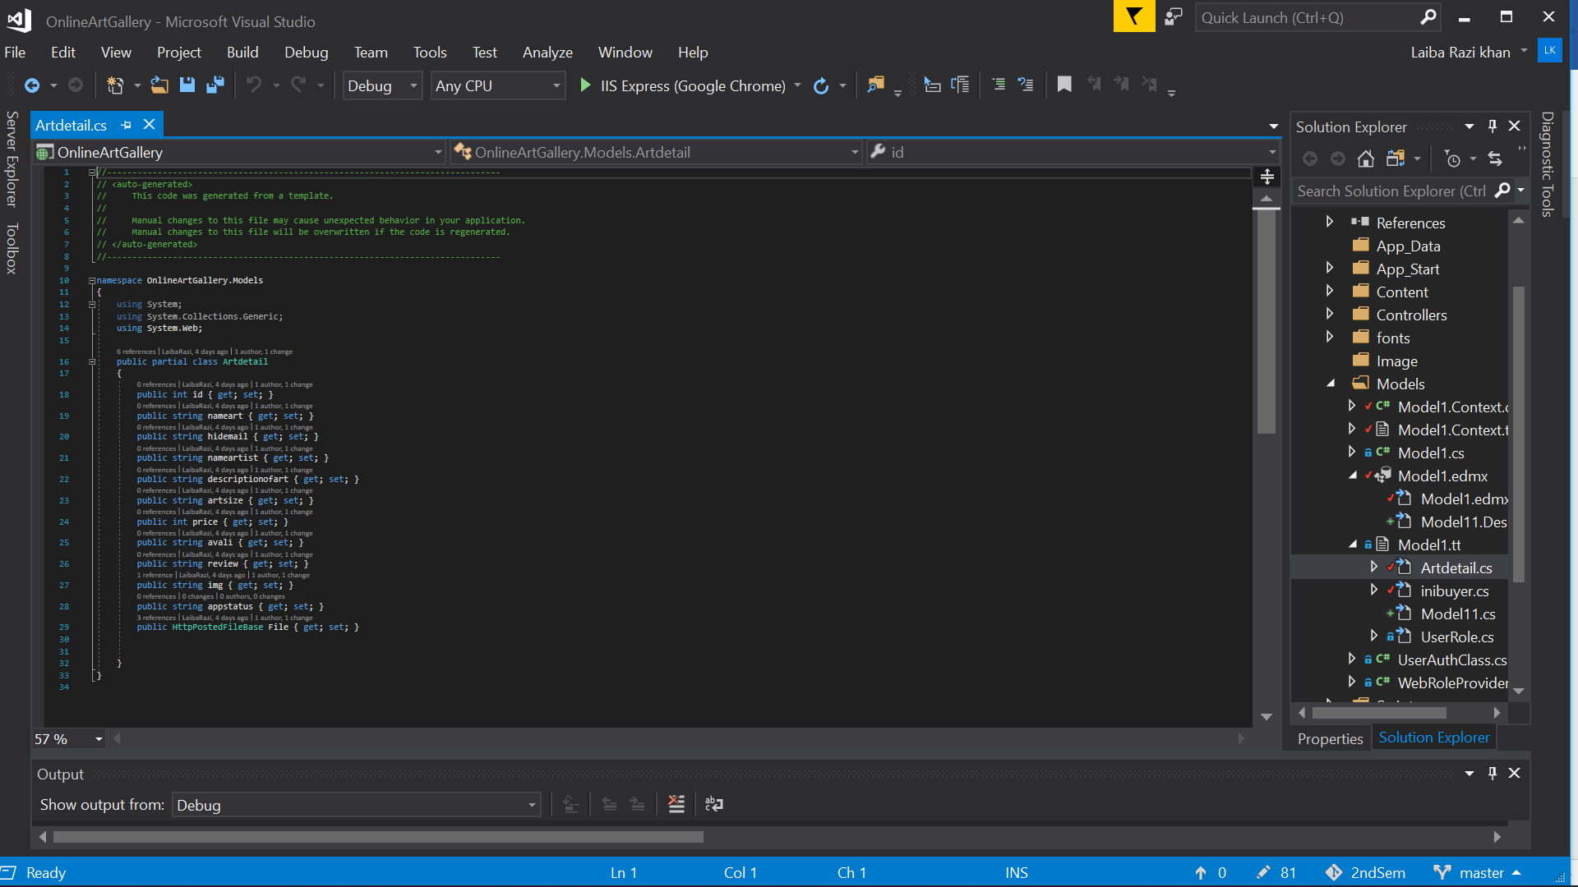

VIEW:

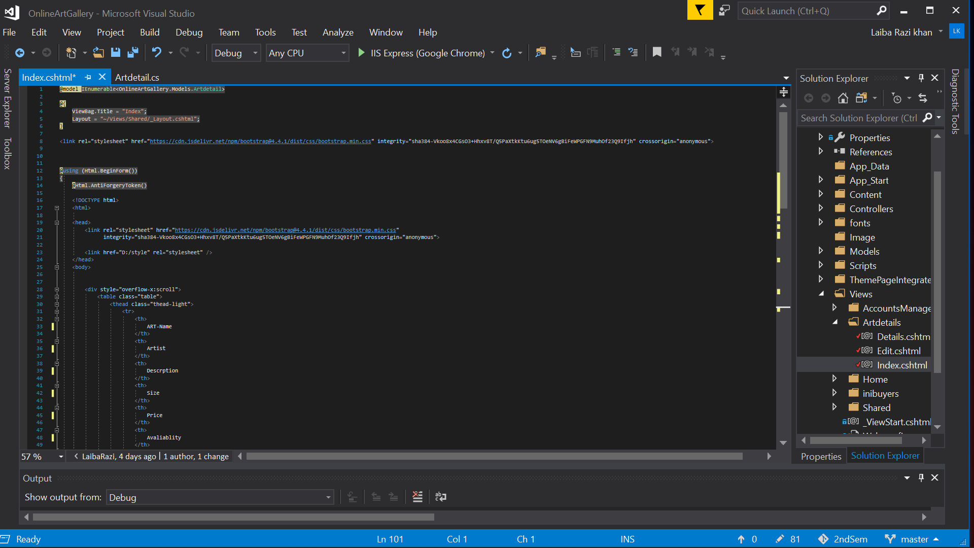

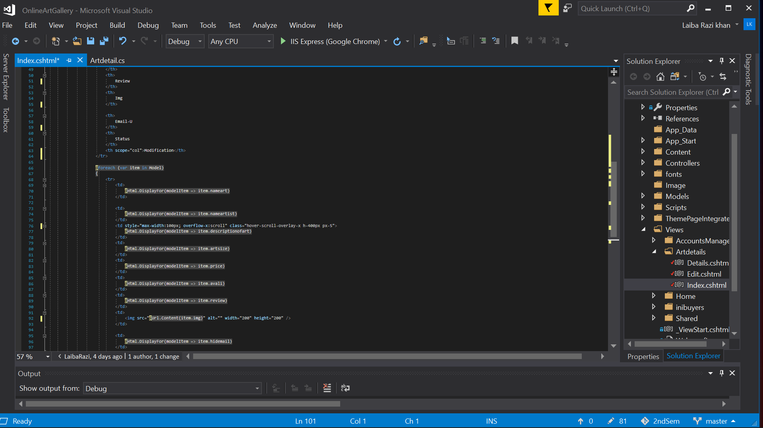

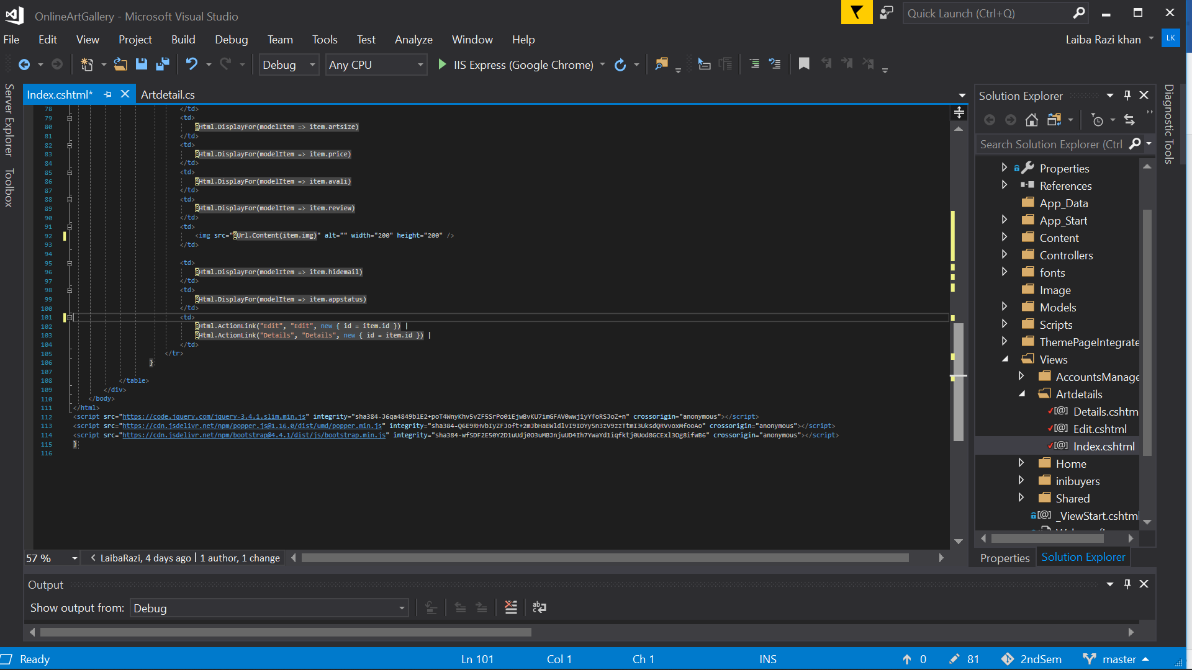

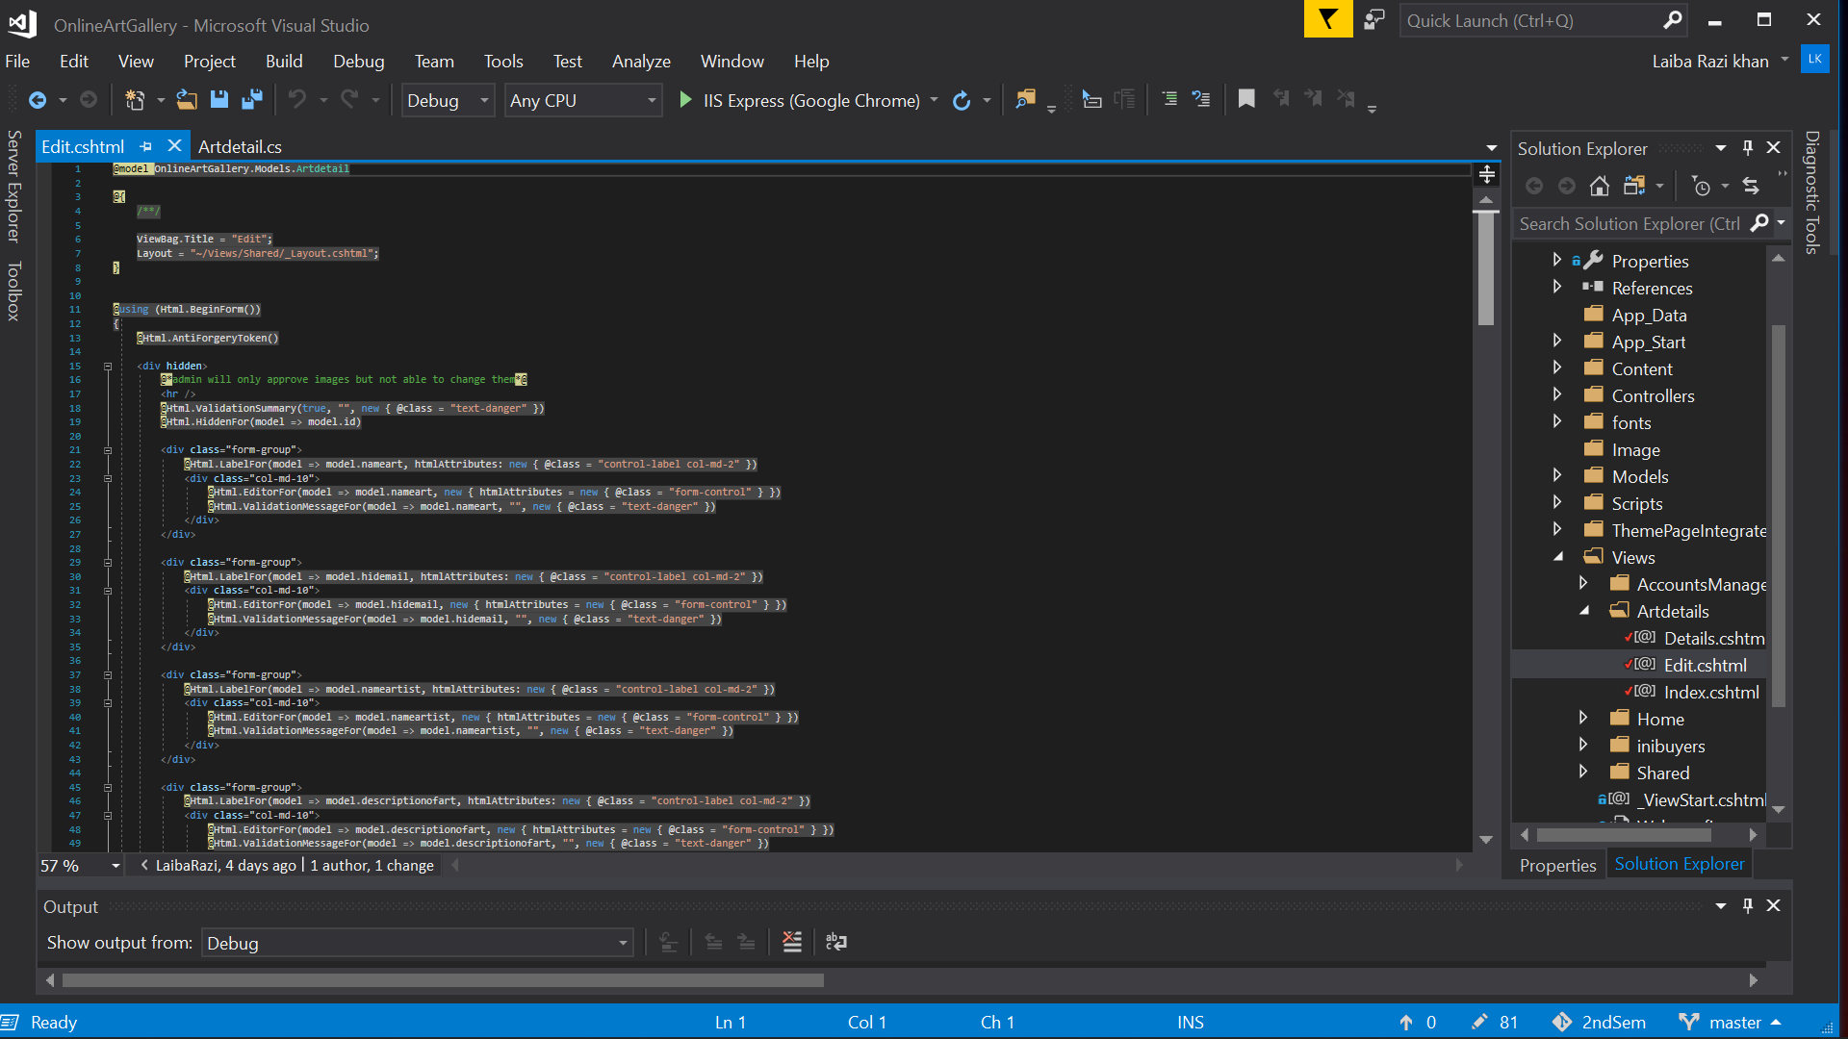

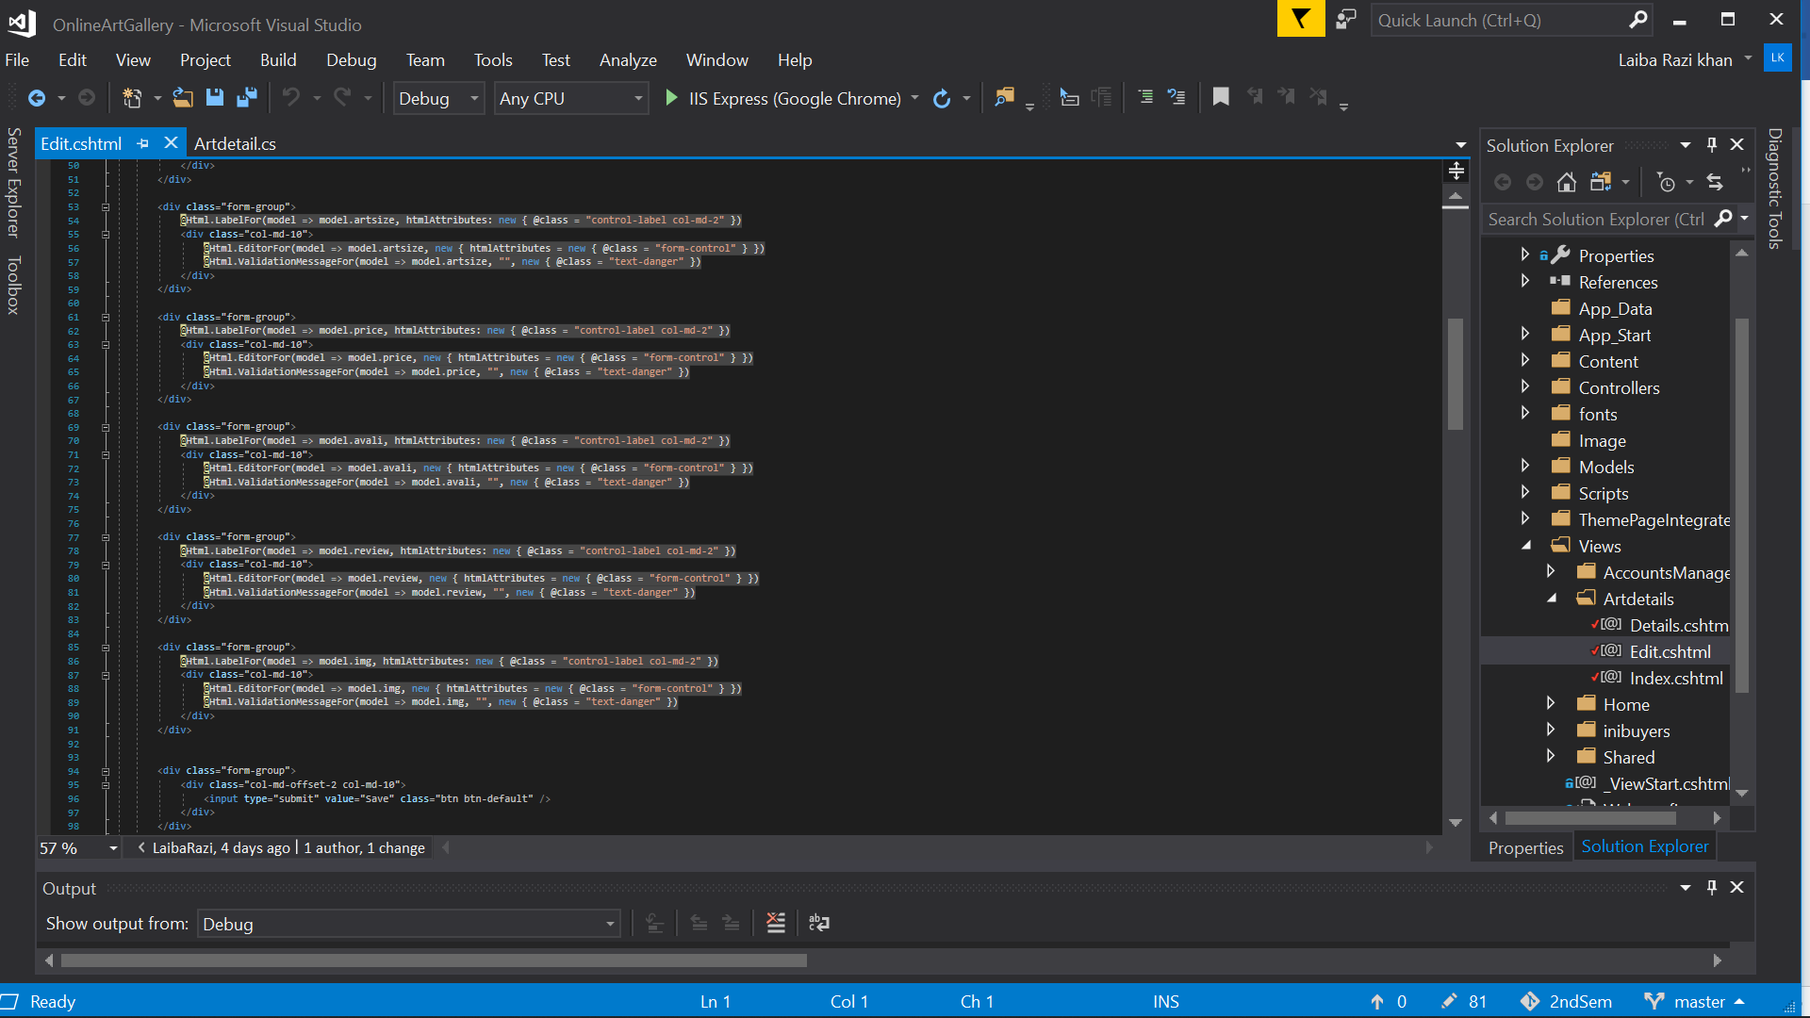

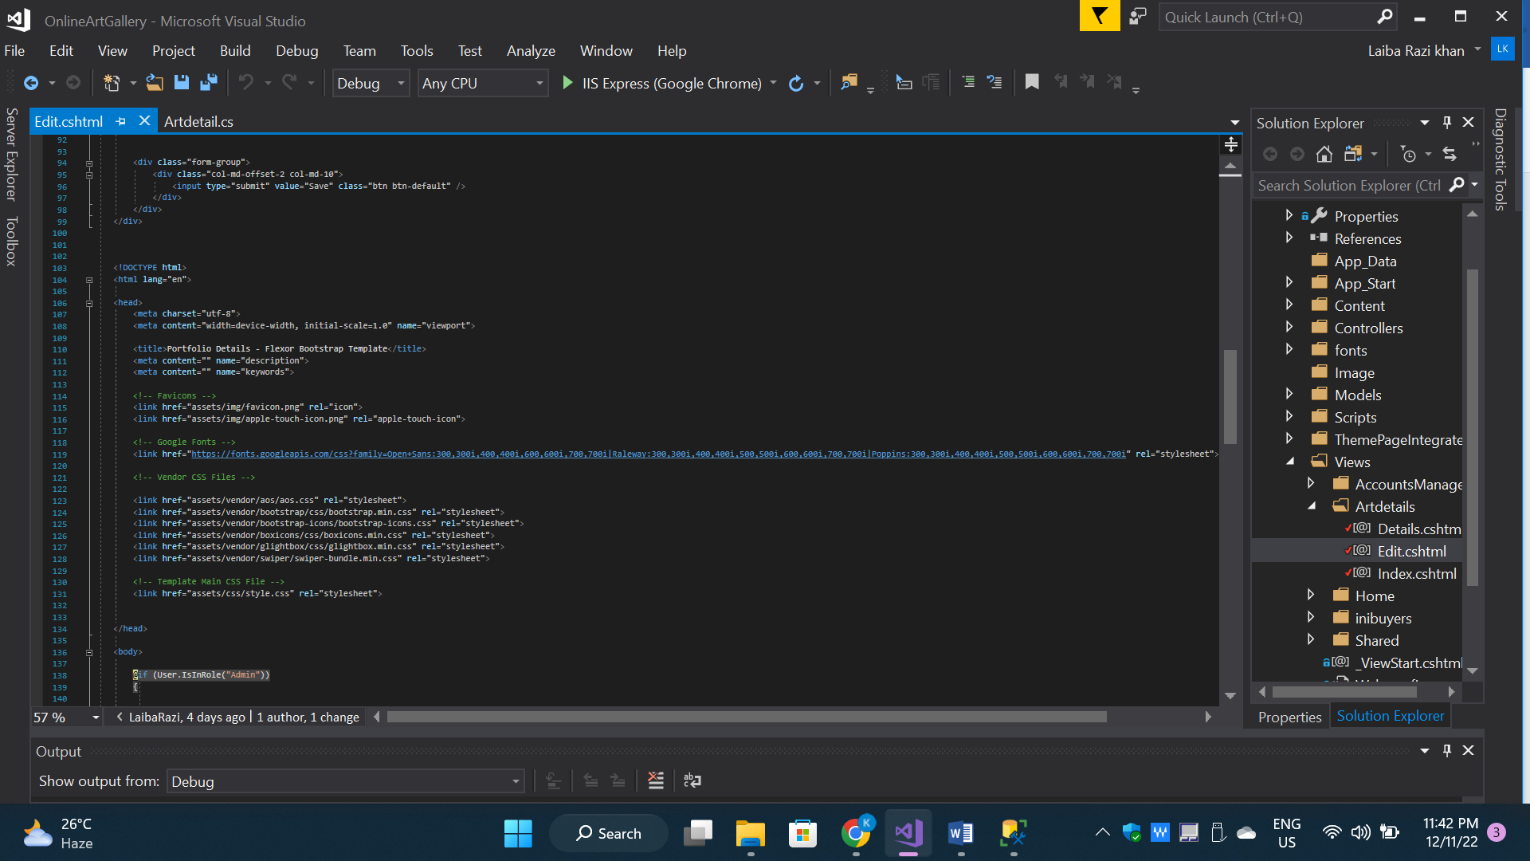

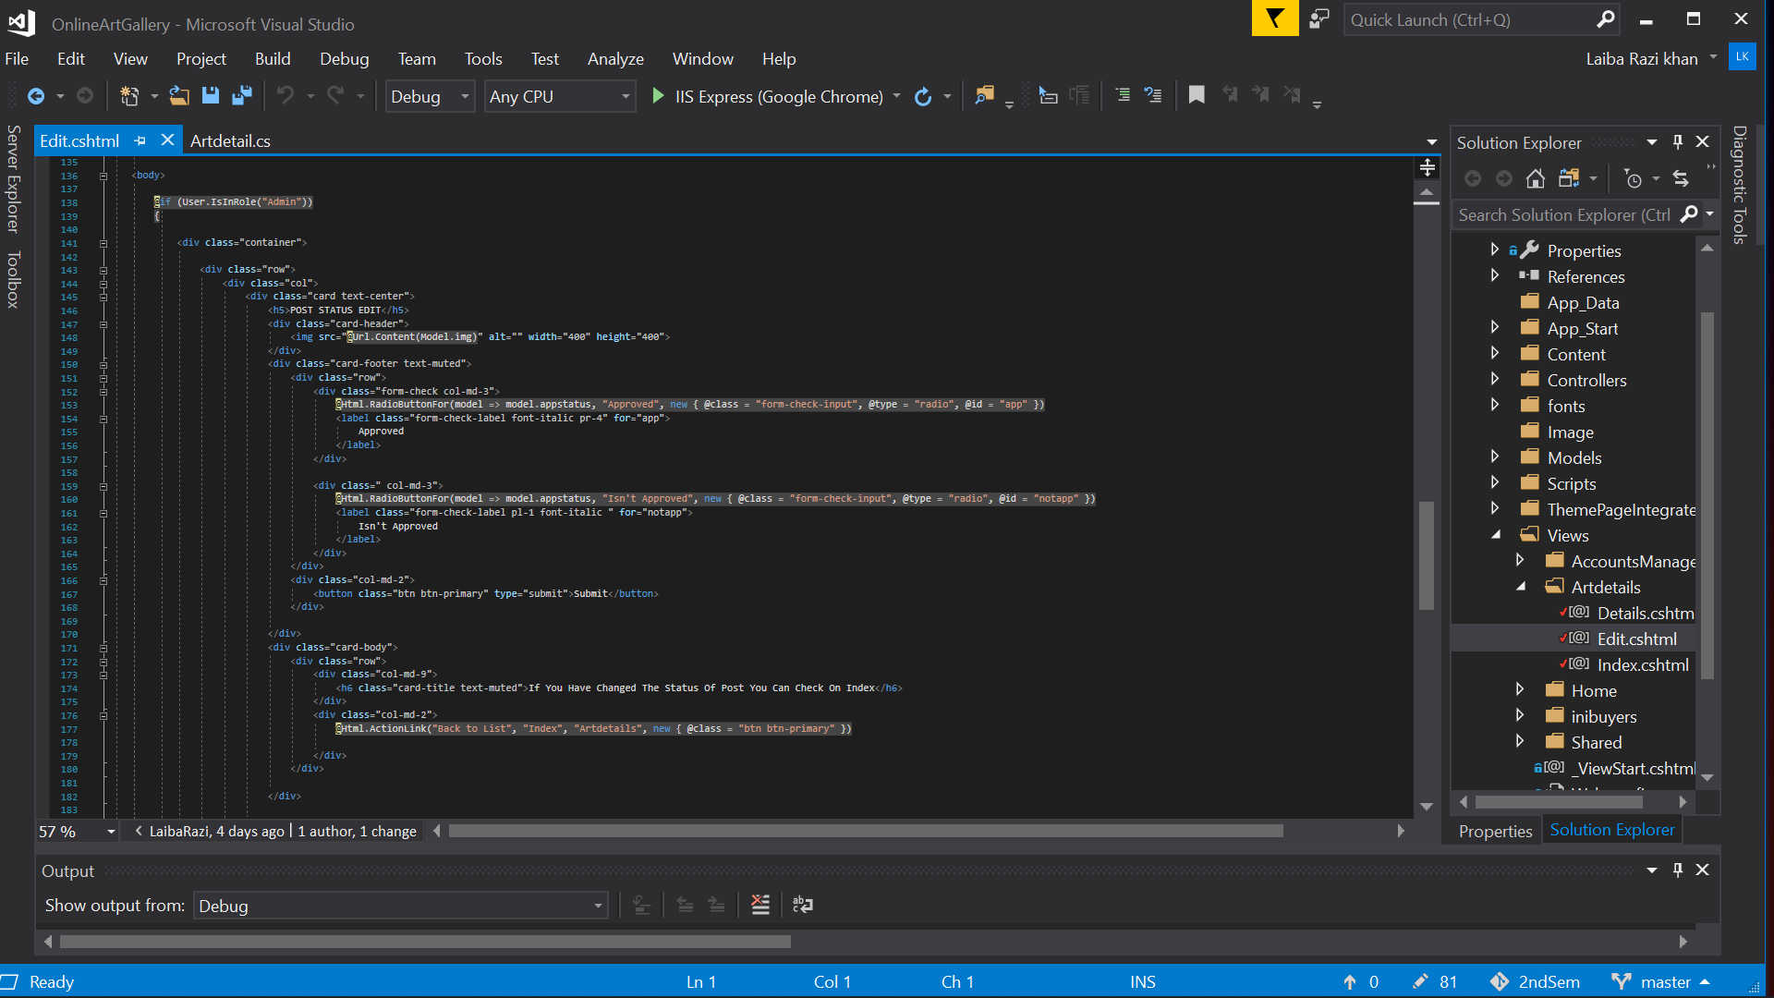

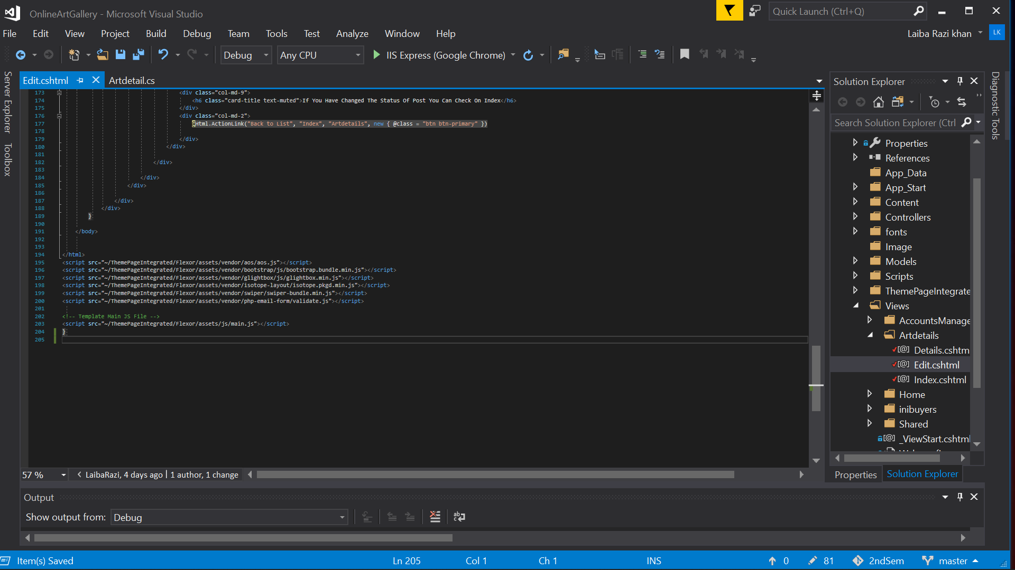

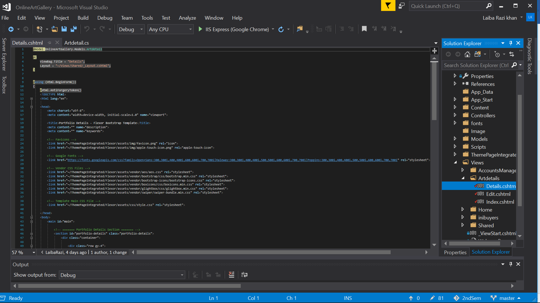

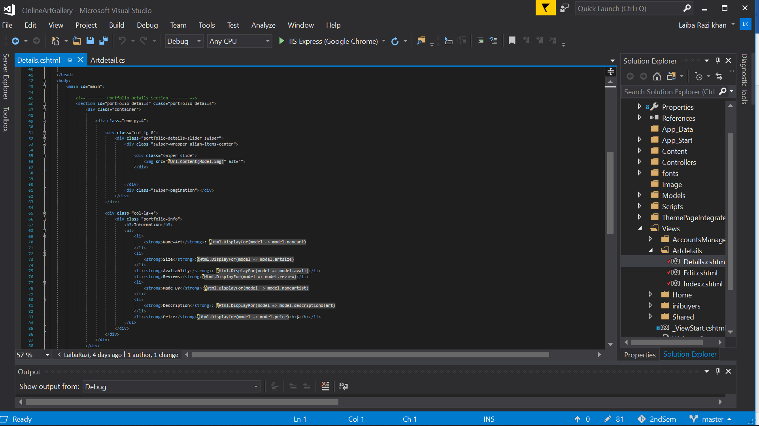

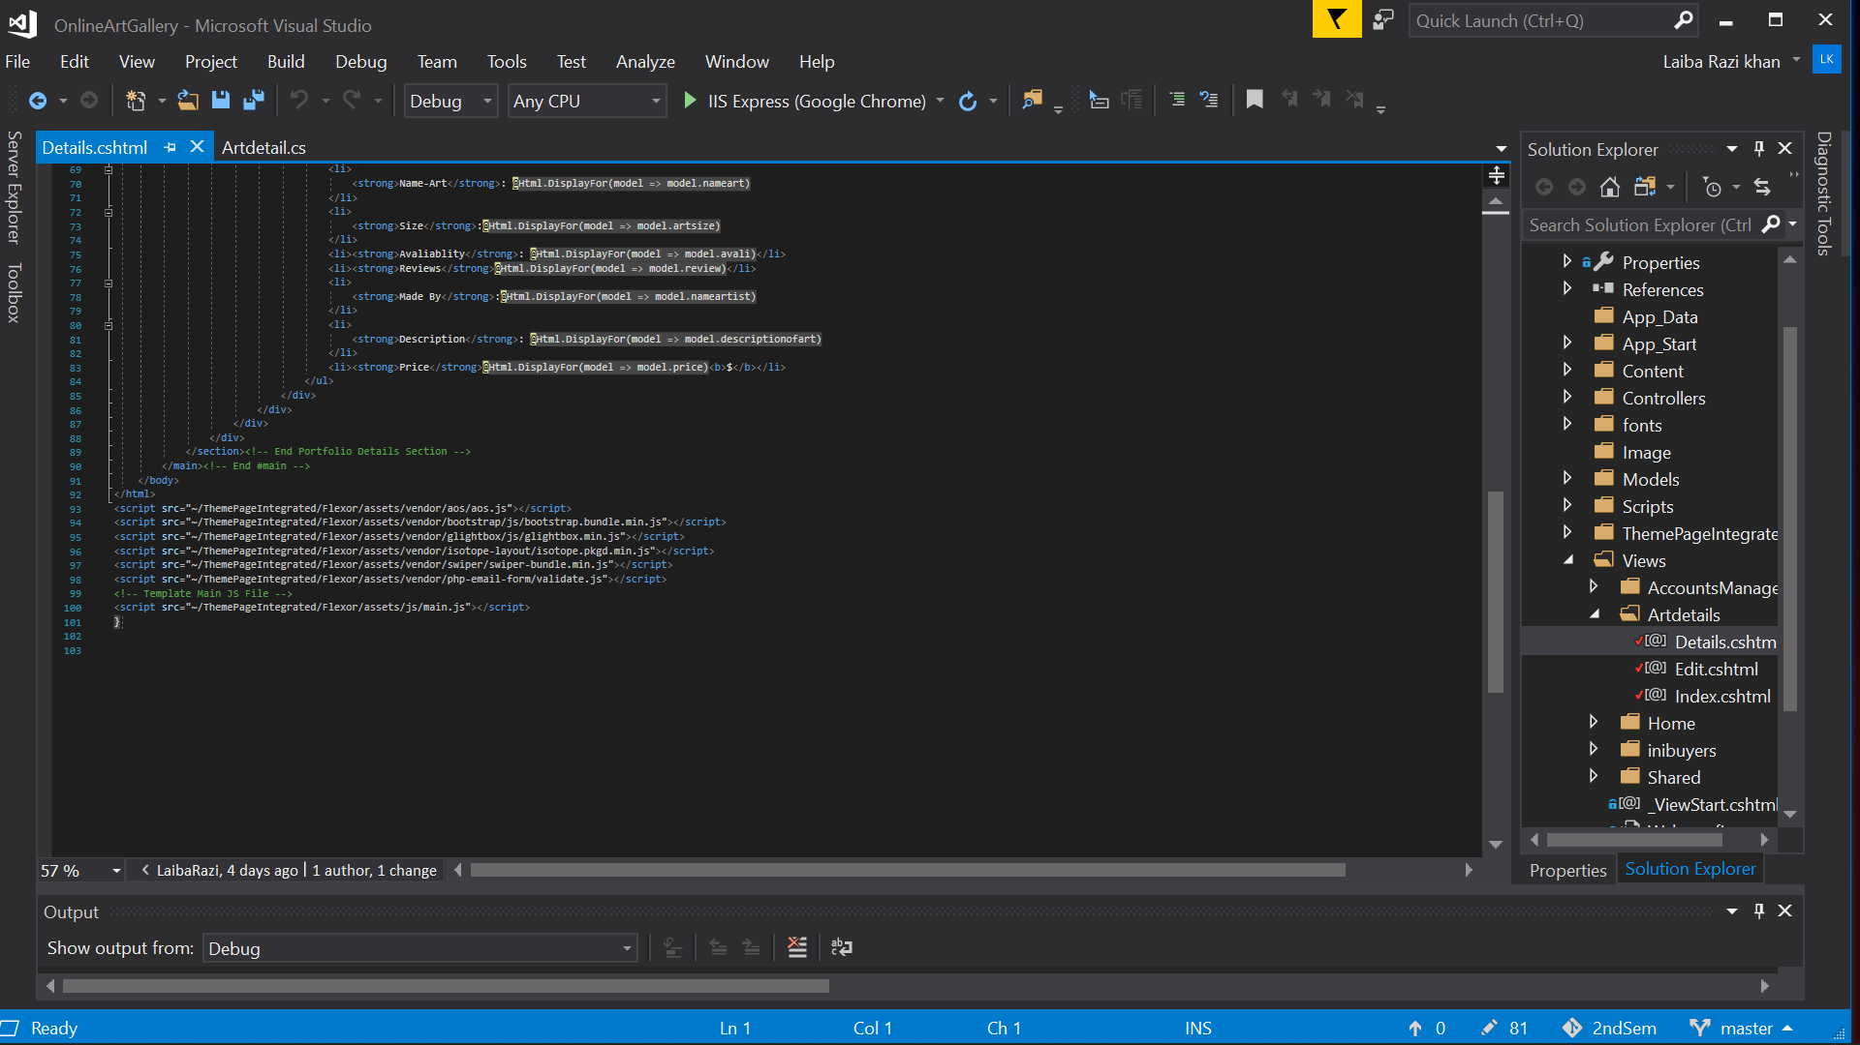

CONTROLLER:

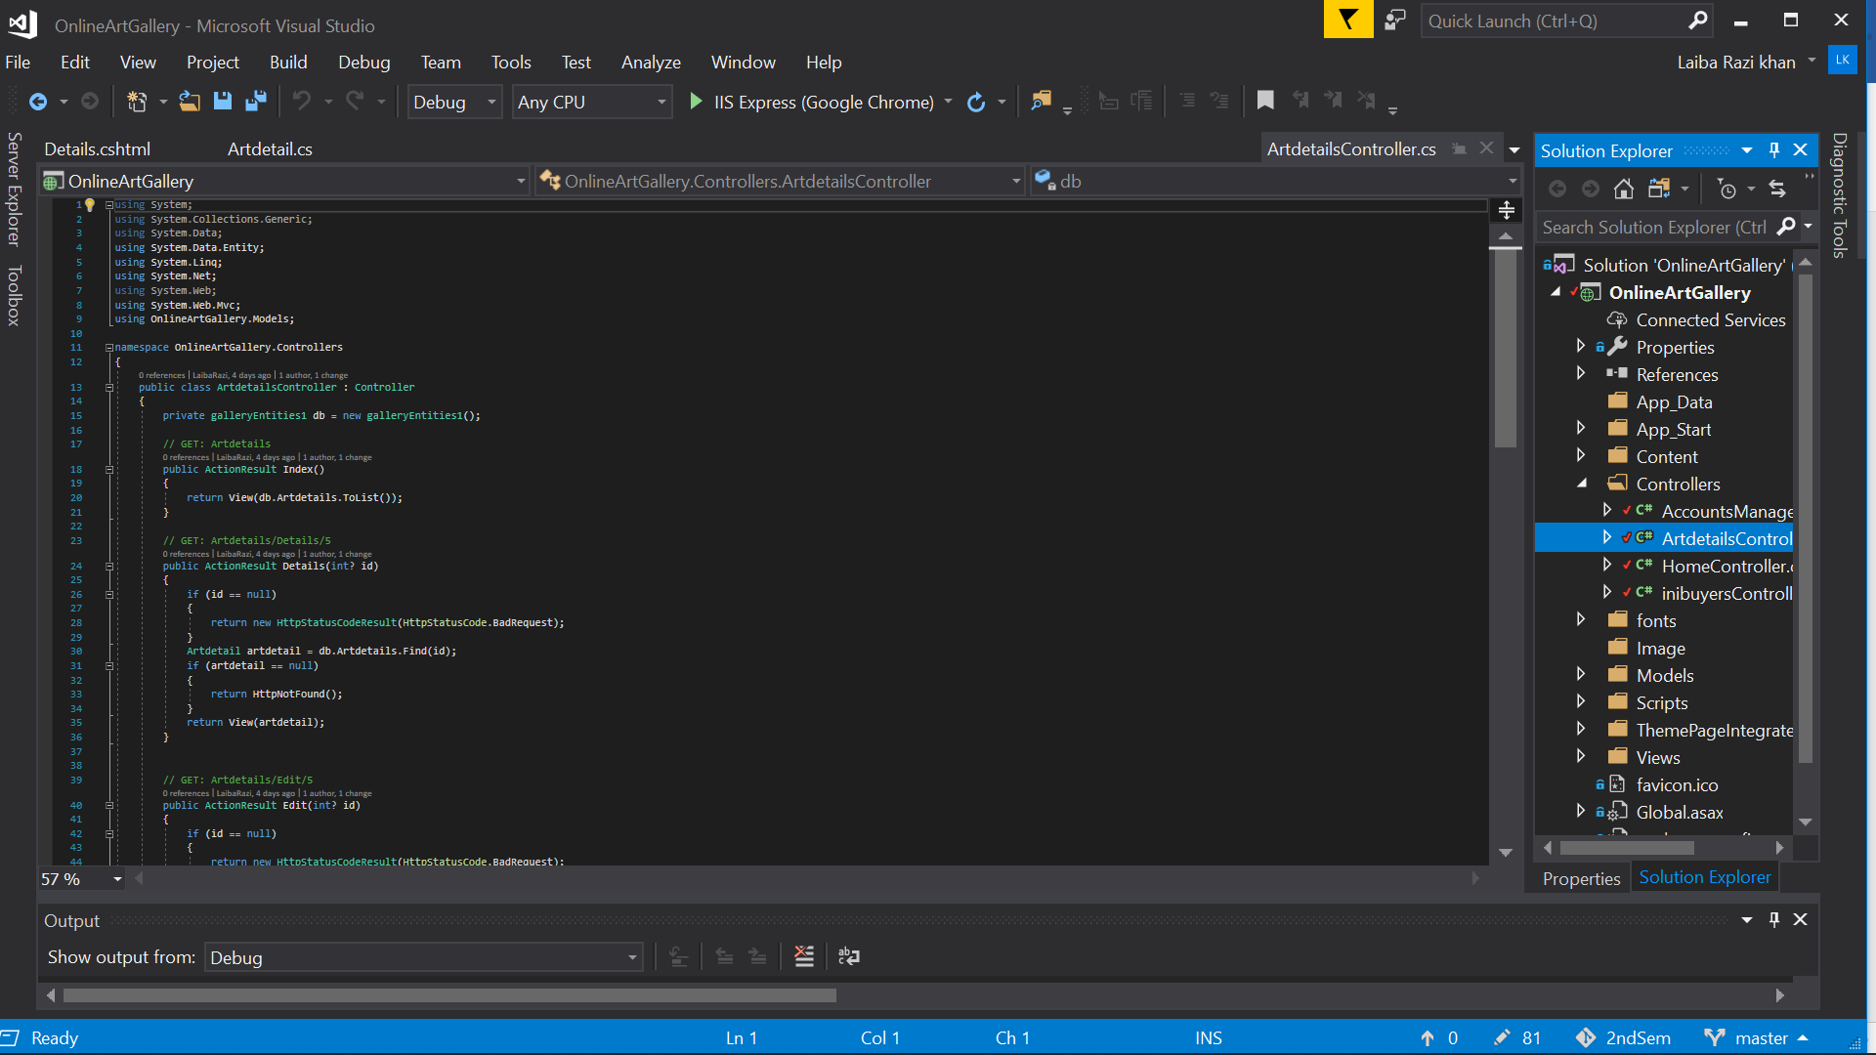

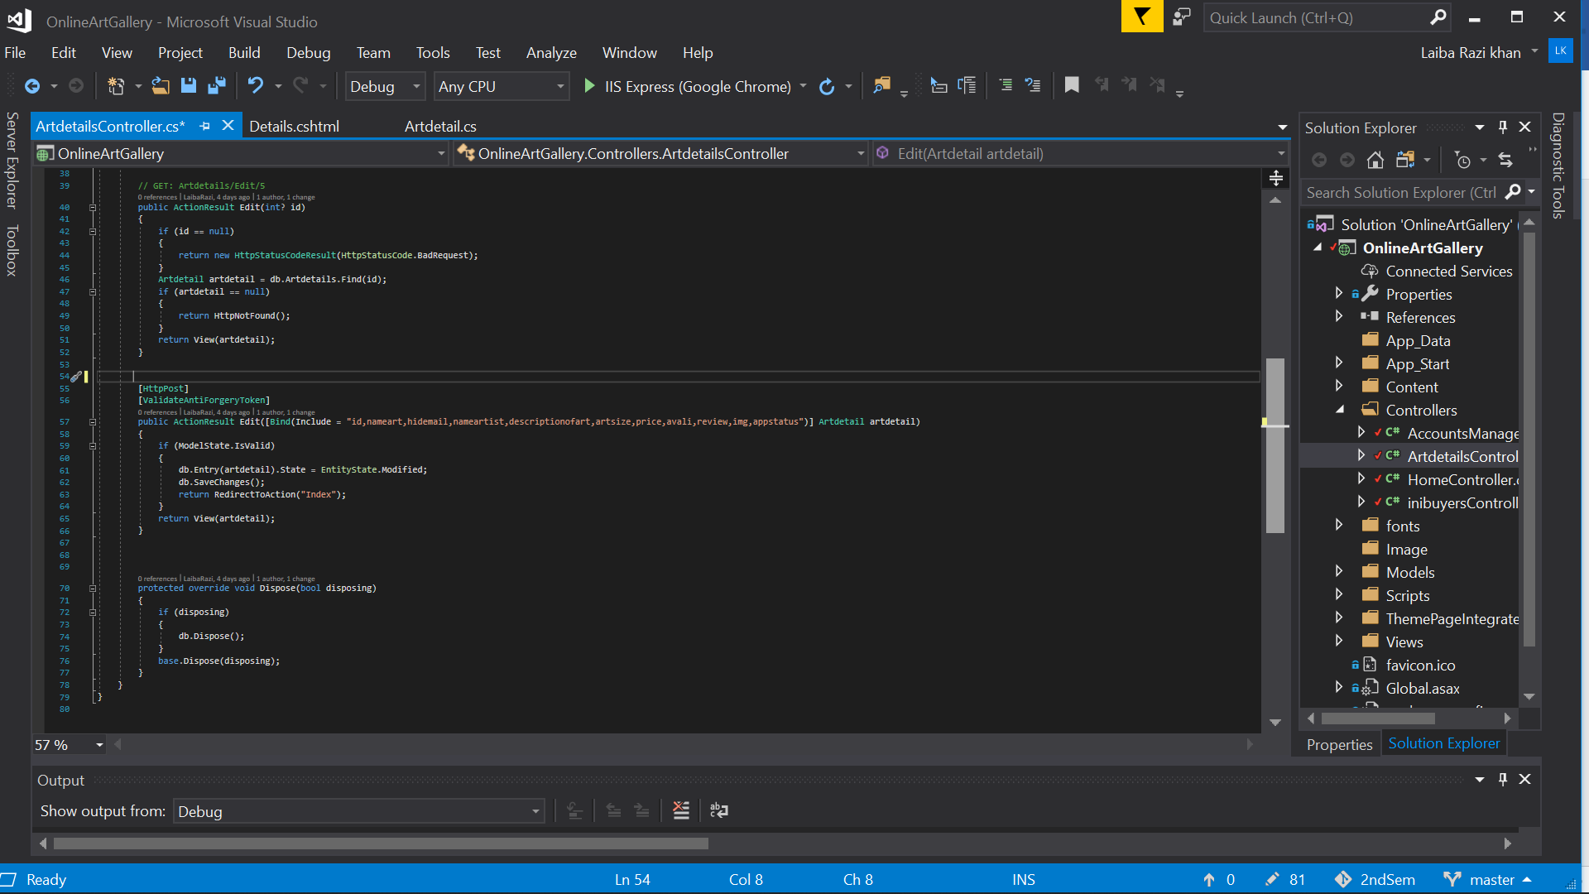

**2.5 LAYOUT**

VIEW:

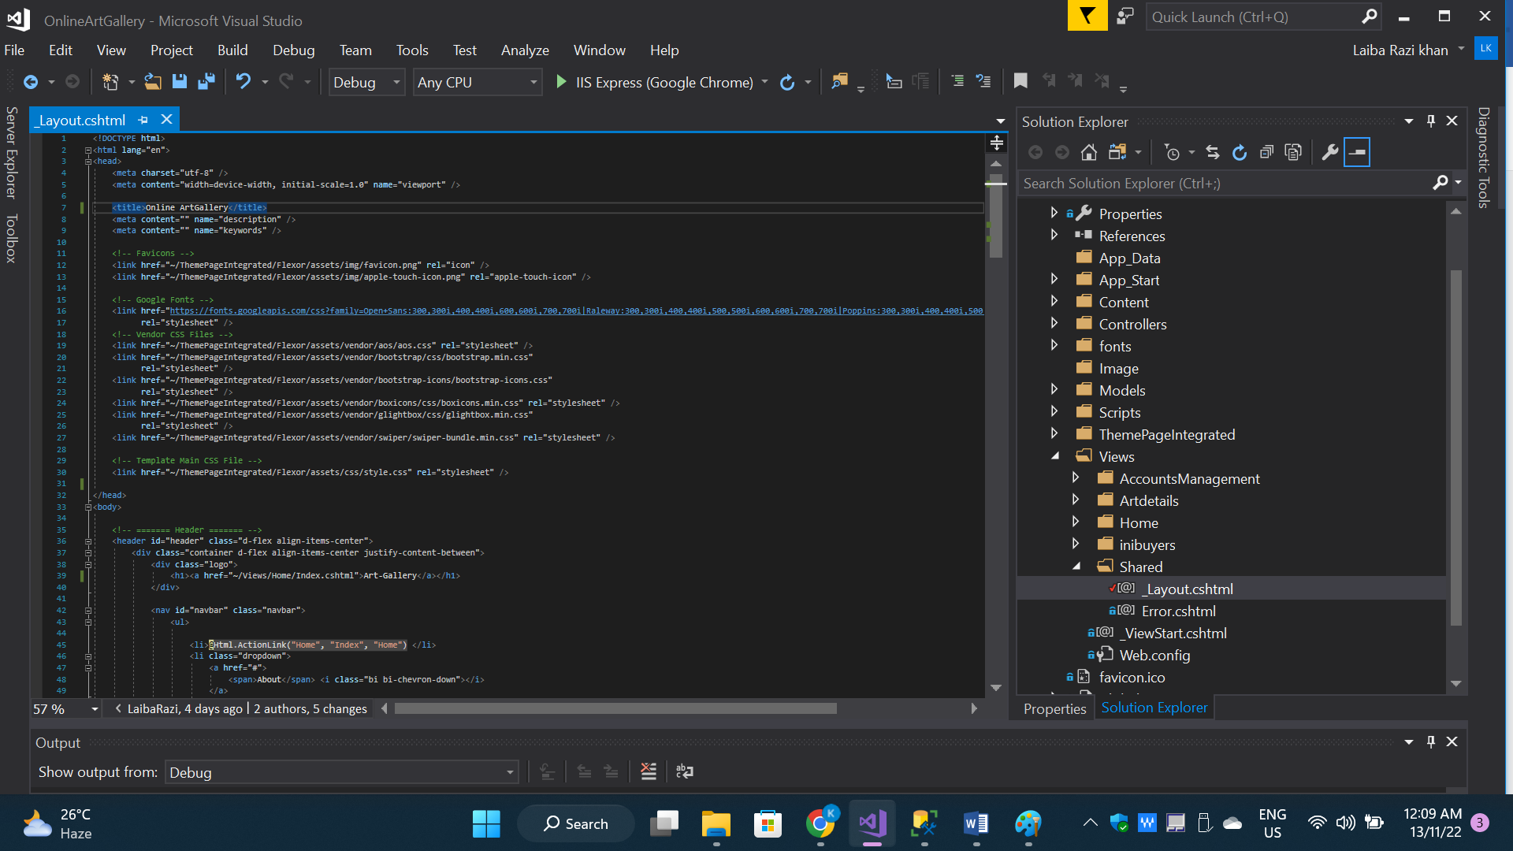

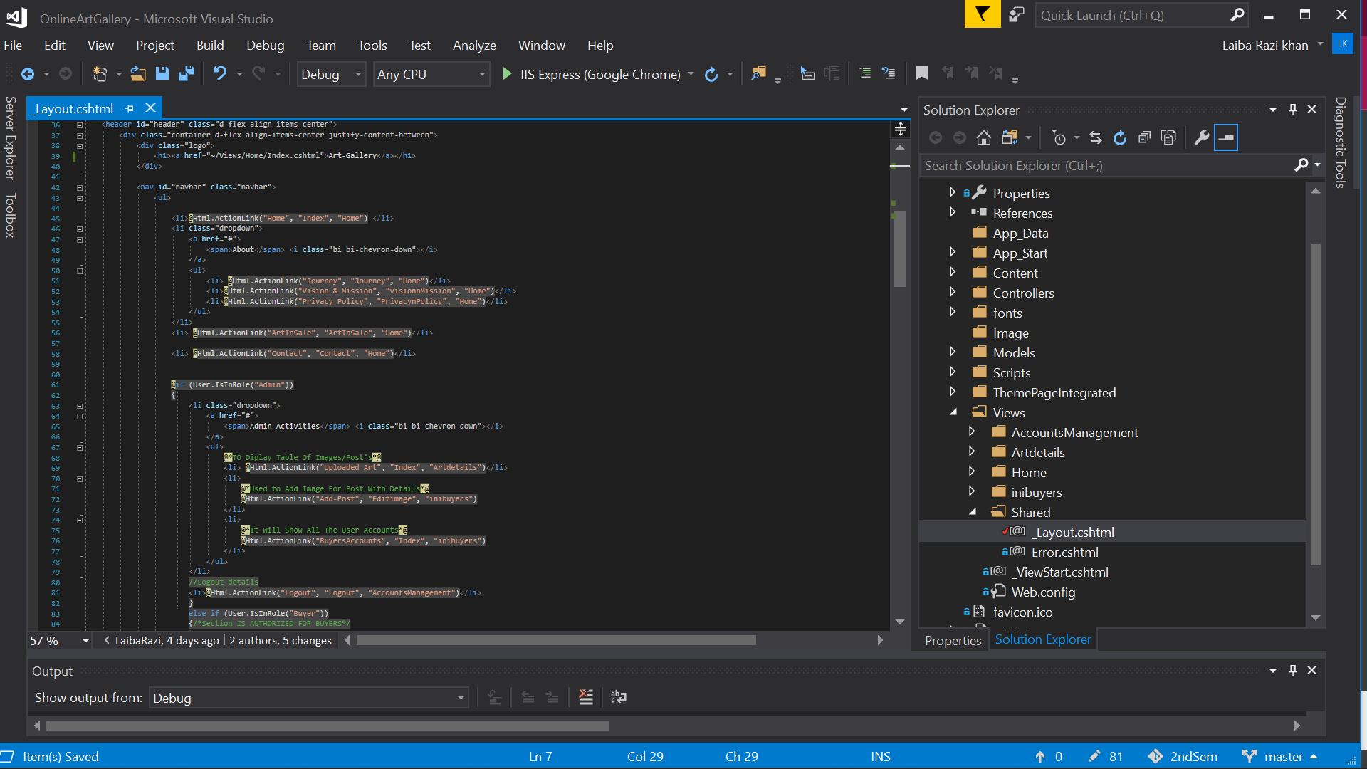

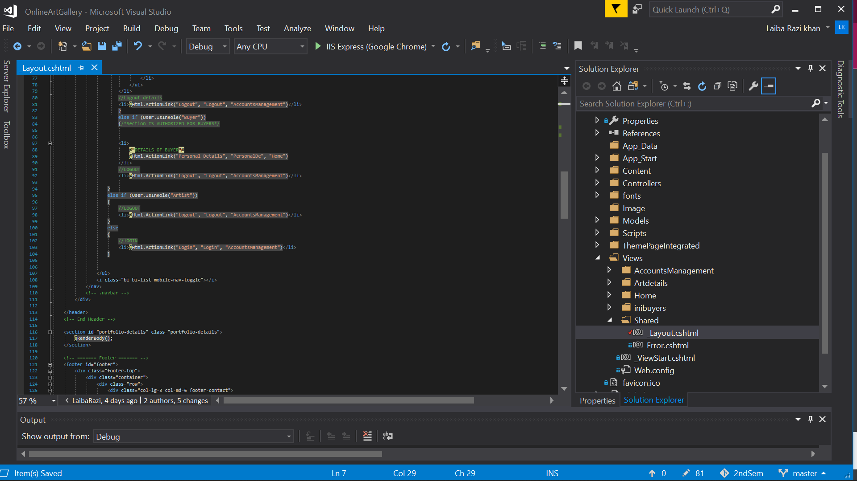

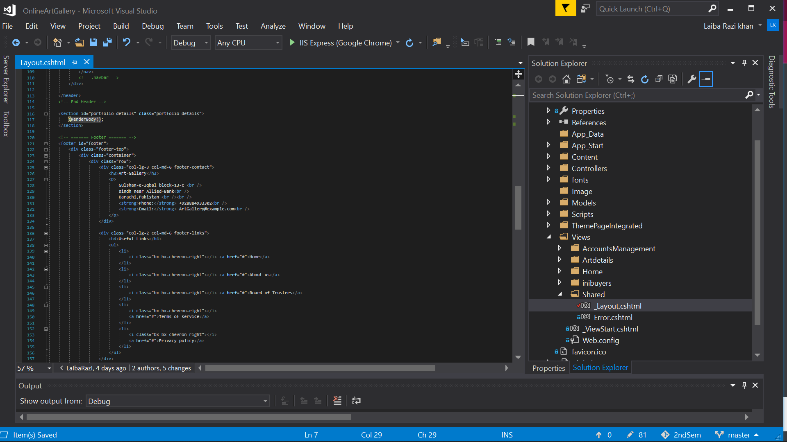

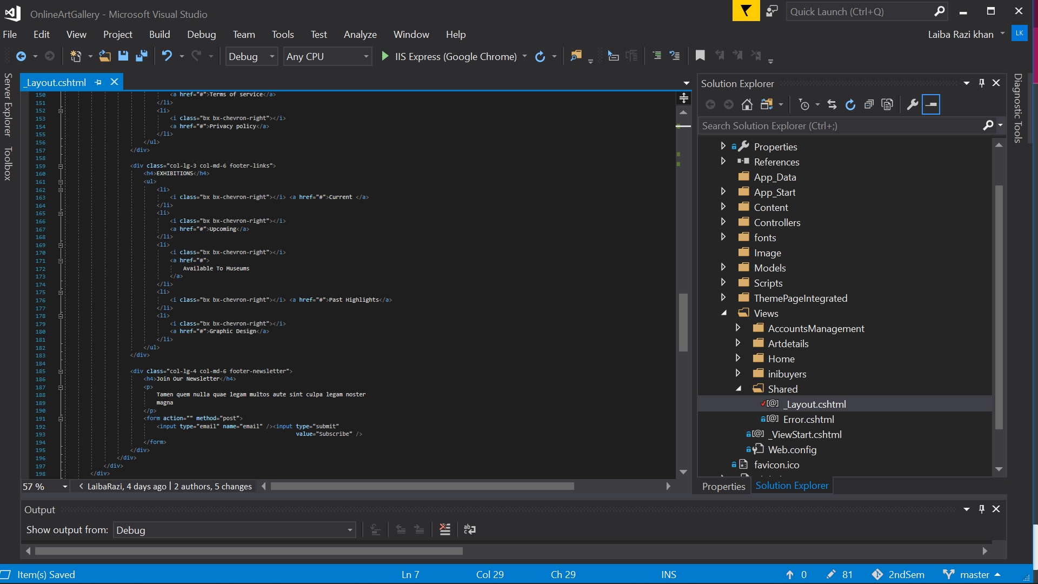

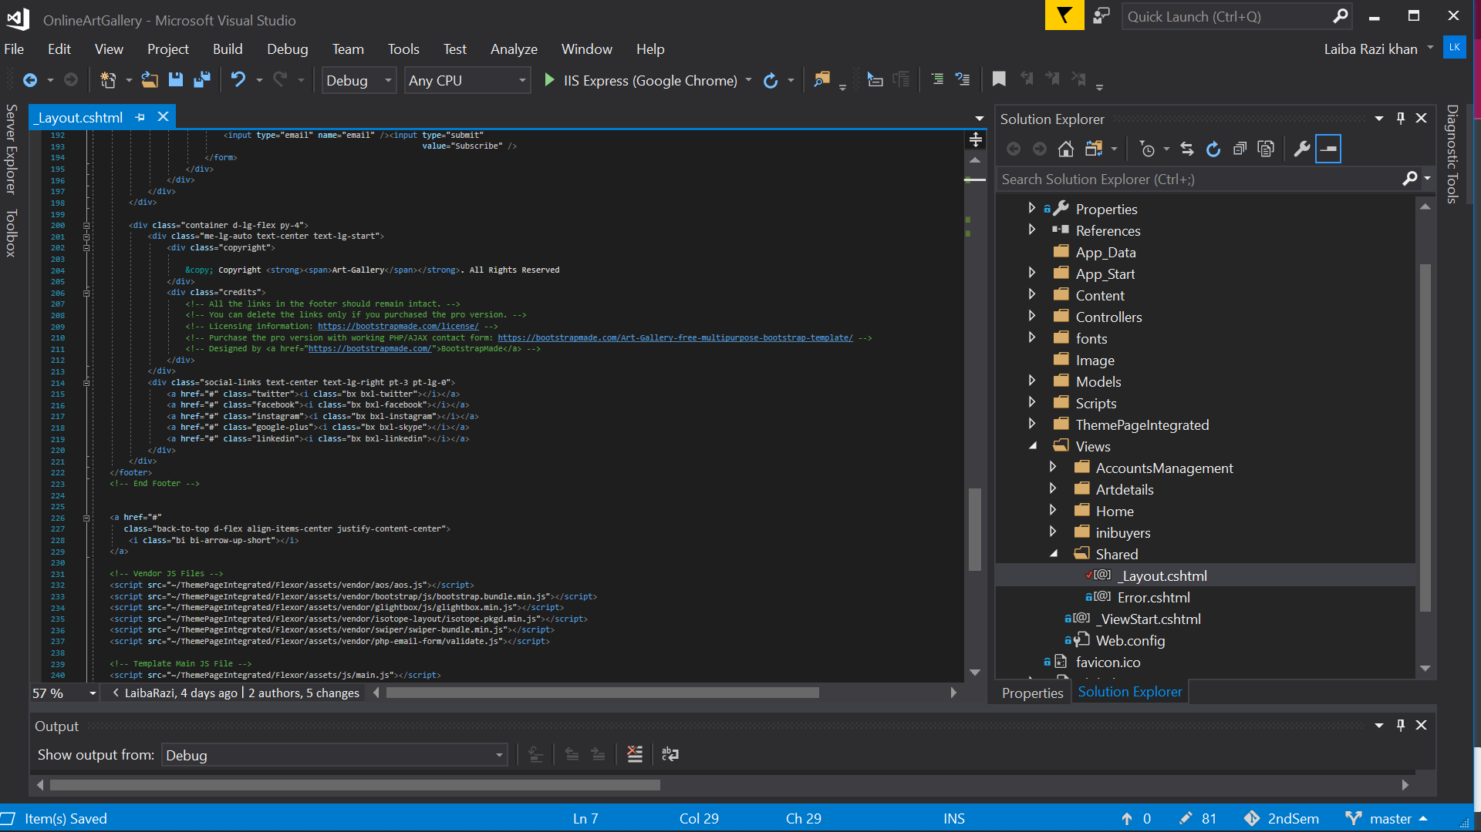

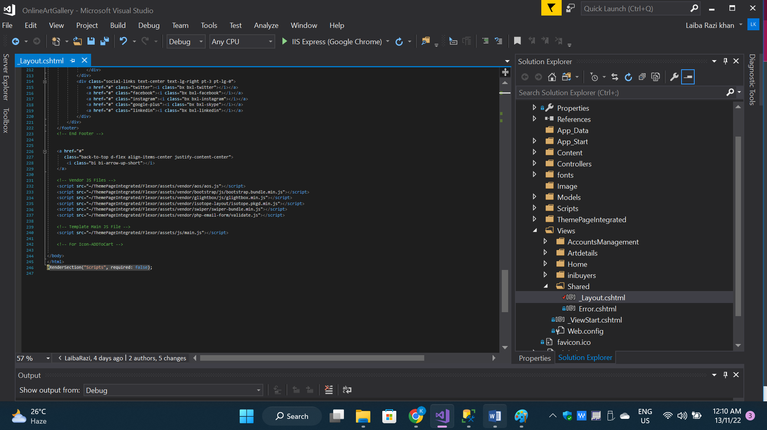

**2.6 SQL QUERIES**

**Note:** You have to insert all hard coded queries to get access of Admin page & once you have inserted hardcoded queries than admin[Email ‘root’ Password ‘root’].

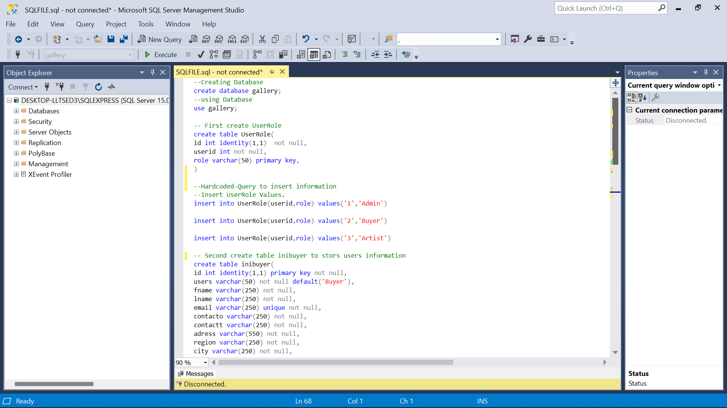

Hardcoded values

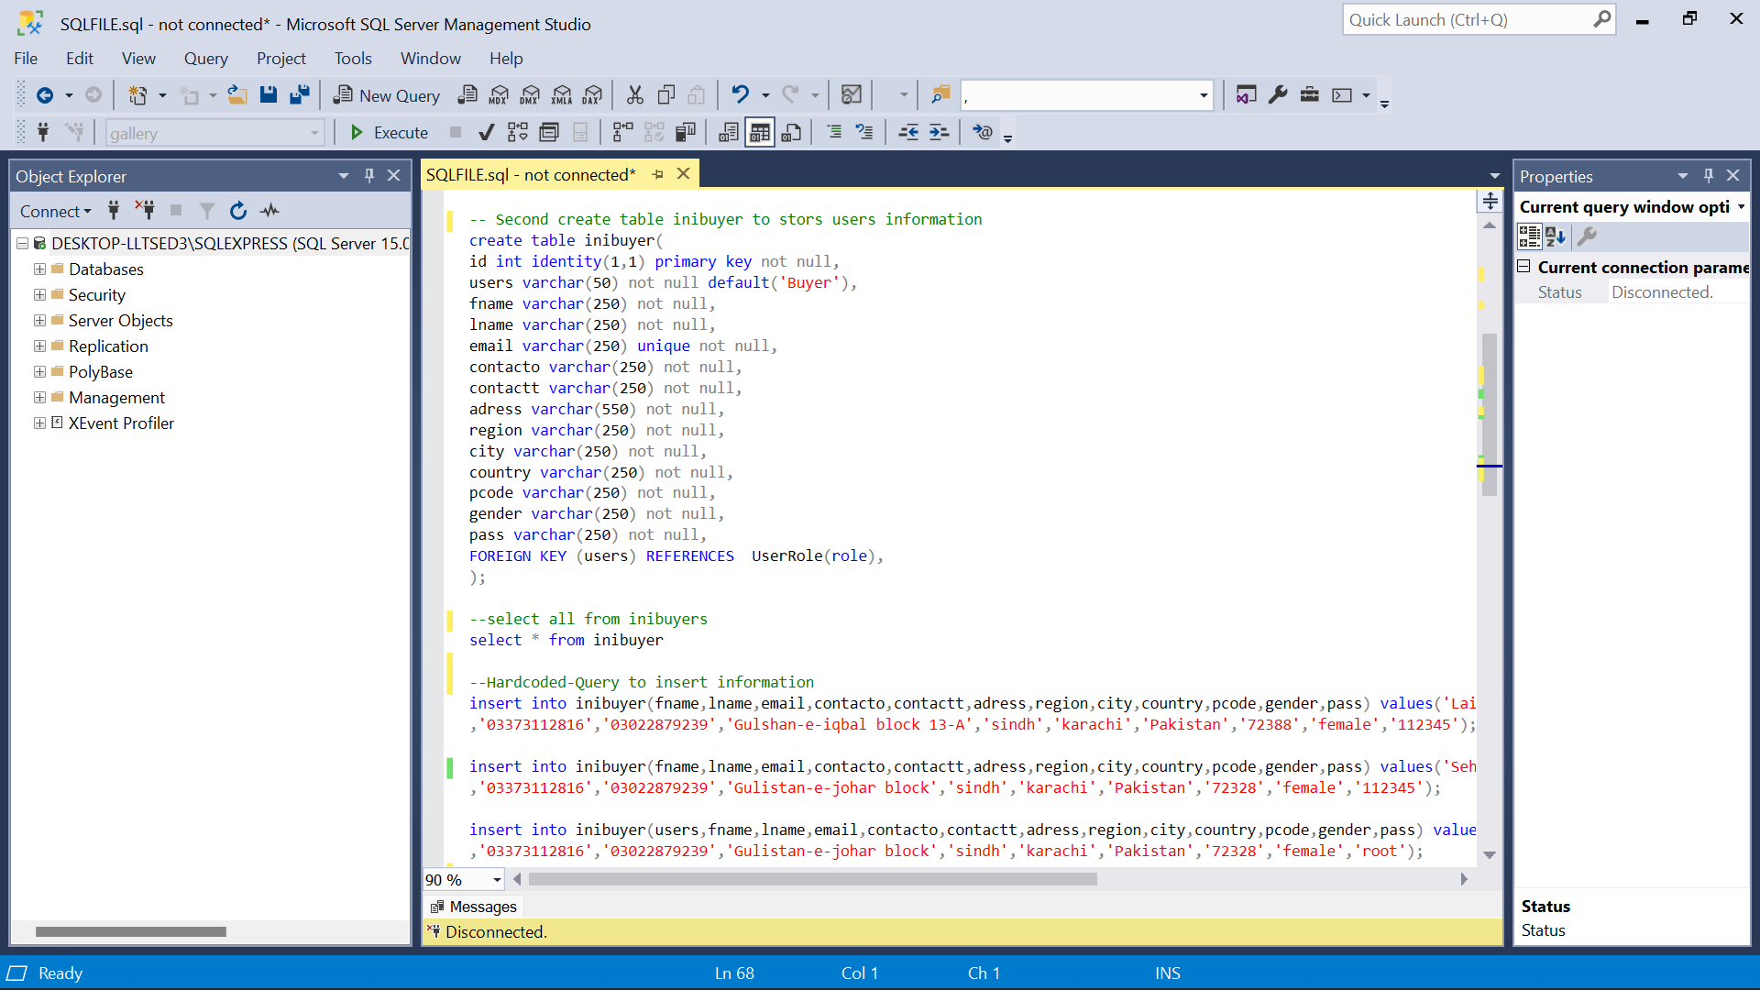

Hardcoded values

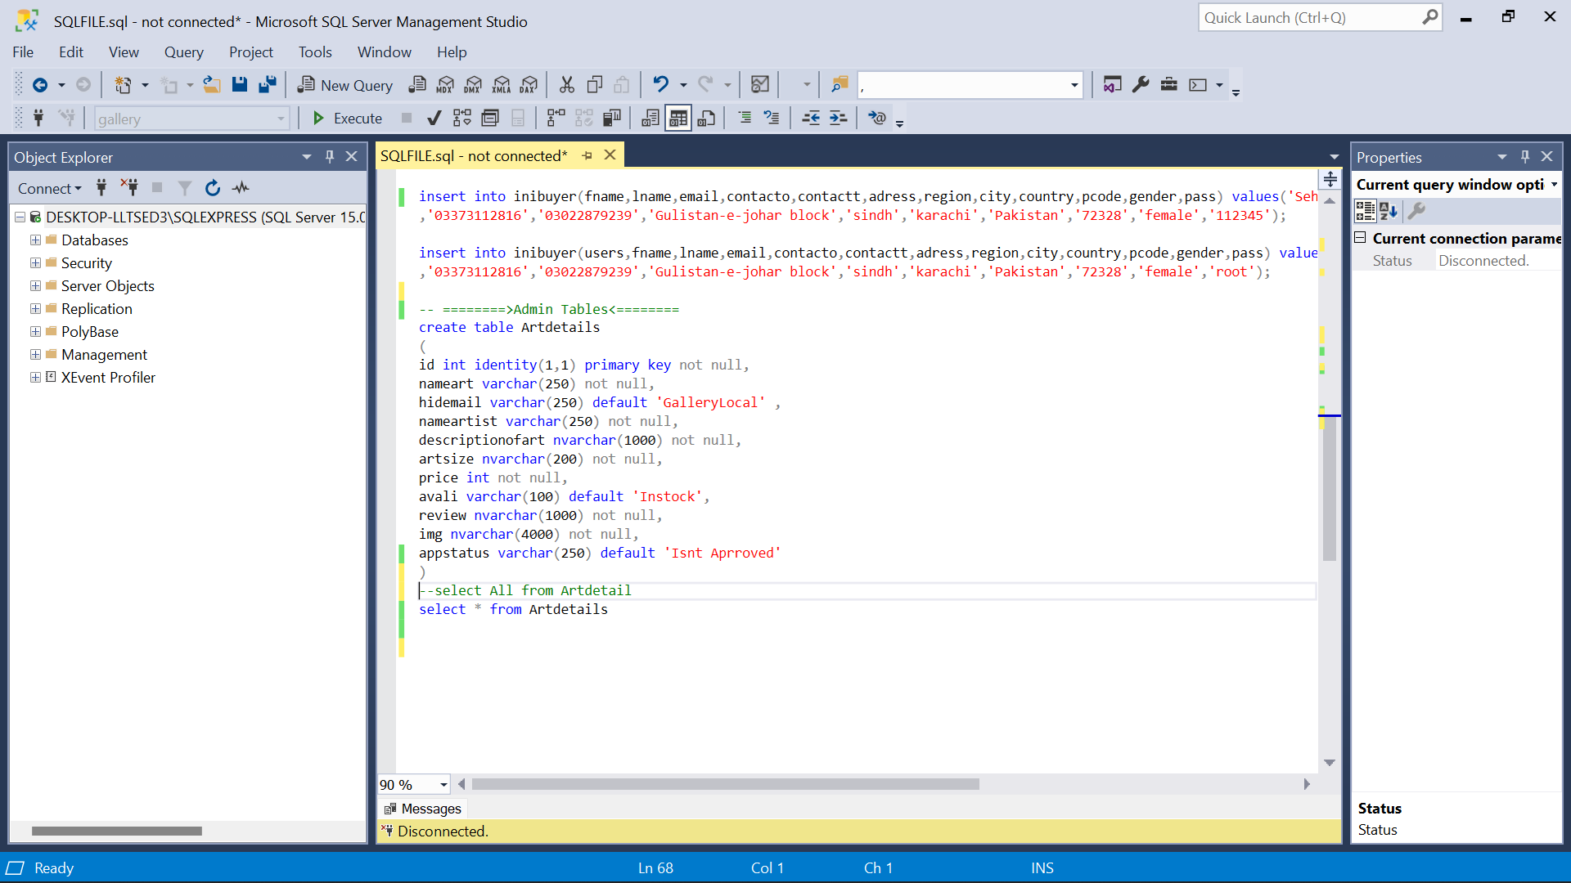

**E-PROJECT SYNOPSIS:**

* Helped Us to understand real project problems.
* Better understanding of UserRoles and DataHiding.
* Makes Us better with Ado.Net Models.
* Usage of Session for effective Data fetching.
* Enhance skills and add value.

**E-PROJECT ANALYSIS:**

* SQL INVOVLED[YES].
* ASP.NET MVC -DATABASE FIRST APPROACH[YES].
* ENTITY FRAME WORK IS USED.